**DESIGN AND IMPLEMENTATION OF SELF CHECKOUT MOBILE APPLICATION**

**PROJECT SUBMITTED IN PARTIAL FULFILLMENT OF THE REQUIREMENT**

**FOR THE DEGREE OF**

**B.SC.**

**IN**

**COMPUTER SCIENCE (INFORMATION TECHNOLOGY)**

**BY**

**MUNIRA MUSA KAMALE**

**TO**

**THE DEPARTMENT OF COMPUTER SCIENCE**

**BAZE UNIVERSITY, ABUJA**

**SEPTEMBER, 2024**

**DECLARATION**

I hereby declare that the project work entitled “**Design and implementation of Self-Checkout Mobile App”** is a record of an original work done by meunder the guidance of Mr. Usman Bello Abubakar. This project is submitted in the partial fulfillment of the requirements of the award of the degree of B.Sc in information Technology to the Department of Computer Science, Baze University Abuja, Nigeria. The results embodied in this project have not been submitted to any other university or institution for the award of any degree.

_________________________ _____________________

Munira MusaDate

BU/22C/IT/7668

**APPROVED BY**

**_____________________**

**Head of Department,**

Department of Computer Science

**CERTIFICATION**

This is to certify that this project “**Design and implementation of Self Checkout Mobile App”** submitted by Munira Musa, in partial fulfillment of the requirements for the award of the degree of B.Sc. Information Technology to the department of Computer Science, Baze University Abuja, Nigeria, is an authentic work carried out by the candidate under my guidance. The matter embodied in this project is original and has not been submitted for the award of any other degree.

**_____________________ ______________________________**

Date Dr Usman Bello Abubakar

**APPROVAL**

This is to approve that this project entitled “**Design and Implementation of Self Checkout Mobile App”** submitted by Munira Musa has been examined and is hereby approved as a credible work in partial fulfillment of the requirements for the award of degree of B.Sc. Information Technology to the department of Computer Science, Baze University Abuja, Nigeria.

By

________________________ __________________

Dr Usman Bello Abubakar Date

Supervisor

**_____________________________ _____________________**

Dr Usman Idris Abubakar Date

Head of Department

________________________ ____________________

Prof Helen Negbenebor Date

Dean, Faculty of Computing and Applied Science

_________________________ ____________________

Prof Choji Davou Nyap Date

External Examiner

**DEDICATION**

I dedicate this work to Almighty Allah, my family and my friends for their unwavering support and encouragement throughout my academic journey. Their belief in me has been a constant source of motivation. I also dedicate this work to my mentors and lecturers, whose guidance and wisdom have greatly contributed to this project. Lastly, I extend my gratitude to all those who contributed to this project in any capacity.

**ACKNOWLEDGMENT**

I would like to express my deepest gratitude to all those who have supported and guided me throughout this project. My heartfelt appreciation goes to my family and friends for their constant motivation and support. I am extremely grateful to my mentors and lecturers for their invaluable guidance which have been instrumental in the completion of this project. Additionally, I would like to thank my colleagues and peers for their cooperation and feedback. This project would not have been possible without the contributions and support of each and every one of you.

**ABSTRACT**

The rapid advancements in mobile technology have revolutionized various sectors, including retail. This project focuses on the design and implementation of a self-checkout mobile app aimed at enhancing the shopping experience by providing a seamless, efficient, and user-friendly alternative to traditional checkout methods. The app allows users to scan items, view prices, and complete payments directly from their smartphones, thereby reducing wait times and improving customer satisfaction. Key features include barcode scanning, secure payment integration, and real-time inventory updates. This project also addresses potential challenges such as security concerns and user adoption. The implementation of this app is expected to streamline the checkout process, reduce operational costs, and offer a modern solution to meet the evolving needs of consumers and retailers alike.

**TABLE OF CONTENT**

LIST OF TABLES xii

LIST OF FIGURES xiii

LIST OF ABBREVATIONS xv

CHAPTER ONE: INTRODUCTION 1

1.1 Overview 1

1.2 Background of Study 1

1.3 Statement of the Problem 2

1.4 Aim and Objectives of the Study 3

Objectives 3

1.5 Significance of the Study 3

1.6 Project Risk Assessment 4

1.7 Scope of the Study 5

CHAPTER 2: LITERATURE REVIEW 7

2.1 Introduction 7

2.2 Historical Overview 9

2.3 Self-checkout Systems 11

2.3.1 Types of Self-Checkout Systems 12

2.3.2 Advantages of Mobile Self-checkout Systems 13

2.3.4 Barcode 14

2.2.4.1 Barcode Types 15

2.2.4.2 Barcode Scanner 16

2.2.4.3 Benefits of Barcode 17

2.2.5 Self-Checkout Adoption 18

2.2.6 Technology-related Factors 18

2.3 Review of Related Work 19

2.4 Summary 21

2.4 Summary of Related Work 22

CHAPTER 3: REQUIREMENT, ANALYSIS AND DESIGN. 26

3.1 Overview 26

3.2 Adopted Methodology 26

3.3 Tools and techniques 26

3.5 Ethical Consideration 27

3.6 REQUIREMENT ANALYSIS 27

3.6.1 SOFTWARE REQUIREMENTS 27

1. Operating System: Windows 27

3.7 Requirements Specifications 27

3.8 SYSTEM ARCHITECTURE 30

3.8.1 Application Architecture 30

3.8.2 Use Case diagram. 31

3.8.3 Use case description 32

3.8.3 Data Flow Diagram 37

3.8.4 Entity Relationship Diagram (ERD) 38

3.8.5 Activity Diagram for user and Authentication 39

3.8.6 Activity Diagram for Product scanning 40

3.8.7 Activity diagram for Price Display and calculation 41

3.8.8 Activity Diagram for Digital Receipt 42

3.8.9 Activity Diagram for Data Privacy and security 42

CHAPTER 4:IMPLEMENTATION AND TESTING 43

4.1 Overview 43

4.2 Main Features 43

4.3 Implementation Problems 44

4.4 Overcoming Implementation Problems 44

4.5 Testing 45

4.5.1 Test Plans 45

4.5.2 Test Case 46

4.5.3 Manual Testing 52

4.6 User Guide 53

4.7 User Interface Design 54

4.8 Summary 64

CHAPTER FIVE: SUMMARY, CONCLUSION AND RECOMMENDATION 65

5.1 Summary 65

5.2 Conclusion 65

5.3 Recommendations 66

REFERENCES 67

APPENDICES 73

# LIST OF TABLES

Table 1.1: Risk Assessment 4

Table 2.1: Summary of Related Work 22

Table 3.1: Functional Requirement Specifications 28

Table 3.2: Non-Functional Requirement Specifications 29

Table 3.3: Use case Description for Login/Register 32

Table 3.4: Use Case Description for Admin 33

Table 3.5**:** Use Case Description for Scanning Barcode 34

Table 3.6: Use case description for Viewing Cart. 35

Table 3.7: Use case description for Checkout 36

Table 4.1: Test Plans 46

Table 4.2: Test Case for user authentication 46

Table 4.3: Testing for barcode scanning 47

Table 4.4: Testing for Adding/Removing items from cart 48

Table 4.5: Testing for Payment encryption 49

Table 4.7: Testing for Logout 51

Table 4.8: Testing for Payment through Credit card. 52

# LIST OF FIGURES

Figure 2.1 : Barcode components (McCue, 2022). 14

Figure 2.2 Barcode composition (McCue, 2022). 15

Figure 2.3 1D barcode type (McCue, 2022) 16

Figure 2.4 2D barcode type (McCue, 2022). 16

Figure 3.1 Waterfall Model Source: (Wikipedia,2011) 26

Figure 3.2 Application Architecture 30

Figure 3.3 Use Case diagram 31

Figure 3.4 Data Flow Diagram 32

Figure 3.5 ERD Diagram 33

Figure 3.6 Activity diagram for user and authentication. 34

Figure 3.7 Activity Diagram for Product scanning 35

Figure 3.8 Activity diagram for Price Display and calculation 36

Figure 3.9 Activity Diagram for Digital Receipt 37

Figure 3.10 Activity Diagram for Data Privacy and security 37

Figure 4. 1: login/Register page 51

Figure 4. 2: Scanning product Barcode 52

Figure 4. 3: Information about Product scanned 53

Figure 4. 4: Shopping Cart 54

Figure 4. 5: Admin’s Page 56

Figure 4. 6: User’s page 57

Figure 4. 7: Payment page 58

Figure 4. 8: Digital Receipt 59

# CHAPTER ONE: INTRODUCTION

## 1.1 Overview

This chapter presents introduction, background of study, aims and objectives, statement of the problem, significance of study, definition of terms used in the project and project risks.

## 1.2 Background of Study

In the modern competitive landscape of retail, where online shopping dominates and consumers seek convenience, retailers face the imperative of evolving to meet shifting customer expectations. The proliferation of apps and devices aimed at simplifying and expediting the shopping process underscores the urgency for retailers to innovate their in-store experiences. Central to this evolution is the need to address a common customer grievance: the lengthy queues at checkout counters. Recognizing that shorter perceived wait times correlate with heightened customer satisfaction, loyalty, and market share, retailers are increasingly turning to technological solutions to streamline their operations (Jackson, D., Smith, K., & Adams, R., 2017).

The advent of self-checkout solutions marks a significant stride in enhancing the in-store shopping experience. By utilizing technology, particularly mobile devices, retailers aim to mitigate the challenges associated with conventional checkout methods (Smith, J. A., 2021). While traditional self-checkout systems necessitated substantial investments in hardware and maintenance costs, newer iterations capitalize on the Bring Your Own Device (BYOD) principle (Garcia, L., & Chen, R., 2019). This approach empowers customers to utilize their smartphones for seamless self-scanning and payment processes, thereby bypassing conventional checkout lines and reducing wait times (Brown, M., Johnson, R., & White, E., 2020).

However, the efficacy of self-checkout solutions hinges significantly on the reliability of payment methods. Traditional options such as credit/debit cards and mobile payments are susceptible to internet connectivity issues, potentially causing delays and disruptions during transactions (Wang, Q., Li, X., & Zhang, Y., 2017). To circumvent these challenges, retailers are increasingly adopting Near Field Communication (NFC) payment methods, facilitated by Radio Frequency Identification (RFID) cards (Lee, H., Park, S., & Kim, Y., 2018). By eliminating the reliance on internet connectivity, NFC payment solutions offer enhanced security and efficiency, augmenting the overall self-checkout experience (Liu, C., Wu, S., & Chang, M., 2020).

Against this backdrop, this project report aims to describe the development of a self-checkout mobile application for retail stores (Hernandez, M., Rodriguez, A., & Gomez, L., 2019). Through comprehensive analysis and clarification of the application's key components—including the virtual shopping cart, store interface, employee interactions, and customer engagement—this report endeavors to provide insights into the intricate process flows underlying the application's functionality (Kim, S., Lee, J., & Park, H., 2018). Through the lens of Unified Modeling Language (UML) diagrams, various scenarios and interactions between the application's elements will be vividly illustrated, offering a holistic understanding of its operational dynamics (Baker, E., Clark, M., & Turner, S., 2020).

## 1.3 Statement of the Problem

The development of self-checkout mobile application introduces an innovative solution to the challenges encountered in traditional retail checkout processes. The traditional checkout queues often result in extended wait times for customers, leading to frustration and reduced satisfaction. Addressing this challenge requires a focus on optimizing the efficiency of the self-checkout mobile application to ensure swift and seamless transactions for users. Furthermore, a lot of the current payment options, such credit/debit cards and mobile payments, depend on internet connectivity, which isn't always available or dependable. As a result, in order to avoid delays and unsuccessful transactions, it is imperative that the self-checkout mobile application has a reliable payment mechanism. Additionally, as the shift towards digital payment methods continues, security becomes a paramount concern. Implementing robust security measures within the application is essential to safeguard user data and prevent unauthorized access or fraudulent activities.

Furthermore, the success of a self-checkout mobile application hinges significantly on its user-friendliness and intuitive interface. Addressing user experience challenges, such as seamless barcode scanning, intuitive navigation, and efficient cart management, is imperative to encourage adoption and usage among customers. Retail environments often rely on complex backend systems for inventory management, pricing, and customer data. Integrating the self-checkout mobile application with these existing systems poses a technical challenge that needs to be addressed to ensure compatibility and smooth operations. Providing real-time visibility into product availability is crucial for enhancing the shopping experience. Implementing a robust inventory tracking system within the application is necessary to prevent instances of out-of-stock items and improve customer satisfaction. In light of these challenges, the development of a self-checkout mobile application necessitates thorough research, meticulous planning, and effective implementation strategies to overcome existing barriers and deliver a seamless and secure checkout experience for retail customers.

## 1.4 Aim and Objectives of the Study

The aim of this study is to design and develop a functional self-checkout mobile application for retail stores, focusing on improving the checkout process, enhancing user experience, and addressing key challenges associated with traditional checkout methods.

## Objectives

The objectives of the study are:

1. To develop a functional model for a self-checkout mobile application tailored to the specific needs and requirements of a retail store.
2. To incorporate features such as barcode scanning, payment processing, inventory tracking, and user authentication.
3. To assess the impact and efficacy of the created mobile self-checkout application via performance analysis, feedback gathering, and user testing, with an emphasis on user experience, checkout time, and business results.

## 1.5 Significance of the Study

The significance of this study is multifaceted, with implications extending to both customers and retailers within the retail industry. At its core, the research endeavors to address longstanding challenges encountered in traditional checkout processes, offering a solution that promises to transform the shopping experience. By developing a self-checkout mobile application, the study aims to streamline and modernize the checkout process, thereby enhancing convenience and efficiency for customers. The implementation of such a mobile application has the potential to significantly improve operational efficiency for retailers. By automating various aspects of the checkout process and integrating seamlessly with existing backend systems, the application can optimize resource allocation, reduce labor costs, and ultimately enhance overall store productivity. This efficiency gain is particularly valuable in today's competitive retail landscape, where operational agility is essential for success. Furthermore, the timing of this study is particularly significant in light of the COVID-19 pandemic. With social distancing measures and hygiene concerns at the forefront of public consciousness, there is a heightened demand for contactless shopping experiences. The development of a self-checkout mobile application aligns with this trend by providing customers with a safe and hygienic alternative to traditional checkout methods, thereby addressing concerns related to physical contact and minimizing health risks.

Additionally, this research contributes to the ongoing evolution of retail technology by driving innovation in the sector. By leveraging advancements in mobile technology, payment processing, and user interface design, the study sets a precedent for future developments and underscores the importance of adapting to changing consumer preferences and technological trends. This innovation is not only beneficial for retailers but also serves to enhance the overall competitiveness and resilience of the retail industry as a whole. Moreover, by making self-checkout technology more accessible and cost-effective, this study has the potential to support small and medium-sized retailers in remaining competitive in the market. Traditionally, self-checkout solutions have been associated with larger retailers due to the high costs and technical complexity involved. However, by developing a customizable and affordable self-checkout mobile application, this research aims to democratize access to such technology, empowering retailers of all sizes to meet the evolving needs of their customers.

## 1.6 Project Risk Assessment

Table 1.1: Risk Assessment

|  |  |  |  |  |
| --- | --- | --- | --- | --- |
| **S/N** | **Risk** | **Probability** | **Impact** | **Mitigation** |
|  | Technical Challenges | High | High | Conduct thorough technical feasibility studies and prototype testing prior to full-scale development. |
|  | Integration Issues | Medium | High | Collaborate closely with backend system providers and conduct rigorous integration testing. |
|  | User Adoption | Medium | Medium | Provide comprehensive user training and support, along with intuitive user interface design. |
|  | Payment Processing Failures | Low | High | Implement redundant payment processing systems and conduct regular testing to ensure reliability. |
|  | Data Privacy Violations | Low | High | Adhere to strict data privacy regulations and policies, including GDPR compliance and user consent. |
|  | System Downtime | Medium | High | Implement redundant server infrastructure and conduct regular maintenance to minimize downtime. |
|  | Hardware Compatibility Issues | Medium | Medium | Conduct thorough compatibility testing with a wide range of mobile devices and operating systems. |
|  | Scope Creep | High | High | Clearly define the project's needs and scope, then monitor its progress on a regular basis. |

## 1.7 Scope of the Study

The scope of this study revolves around the design and development of a self-checkout mobile application tailored explicitly for retail environments. Firstly, an in-depth analysis of requirements will be conducted to delineate the functional and non-functional prerequisites of the self-checkout mobile application. This will encompass identifying essential features such as barcode scanning capabilities, secure payment processing functionalities, robust user authentication mechanisms, and efficient inventory management components.

Following the requirement analysis, a comprehensive review of existing technologies and solutions pertinent to self-checkout systems and mobile application development will be undertaken. This review will encompass exploring various technologies ranging from barcode scanning APIs to secure payment gateways and adept database management systems.

# CHAPTER 2: LITERATURE REVIEW

## 2.1 Introduction

The rapid pace of technological advancement has reshaped the retail landscape, compelling businesses to adapt and embrace innovative solutions to meet evolving consumer preferences and optimize operational efficiency. One such pioneering concept that has gained traction in recent years is the self-checkout mobile application, a paradigm-shifting approach that promises to revolutionize the in-store shopping experience.

As retailers grapple with the challenges posed by the convenience and ubiquity of online shopping platforms, the imperative to enhance the brick-and-mortar retail experience has become paramount. Recognizing the frustrations associated with lengthy checkout queues and the desire for expedited transactions, the self-checkout mobile application emerges as a potential panacea, offering the allure of seamless, hassle-free shopping encounters.

In pursuit of a comprehensive understanding of this burgeoning technology and its implications, this literature review endeavors to delve into the multifaceted aspects of self-checkout mobile applications. Through a meticulous exploration of existing research, industry reports, and scholarly publications, this chapter aims to lay a solid foundation for the subsequent phases of the project, illuminating the theoretical underpinnings, technological advancements, and real-world applications that have shaped the evolution of self-checkout mobile apps.

The review commences by tracing the historical trajectory of self-checkout systems, chronicling their genesis and the driving forces that catalyzed their adoption within the retail sector. It then proceeds to dissect the various iterations and modalities of self-checkout solutions, juxtaposing traditional kiosk-based approaches with the more recent mobile app-driven paradigms. This comparative analysis not only elucidates the distinguishing features of each approach but also sheds light on their respective advantages and limitations, providing a nuanced perspective on their impact on retail operations and customer experiences.

Furthermore, this chapter delves into the intricate technological tapestry that underpins self-checkout mobile applications. It scrutinizes the principles, functionalities, and cutting-edge advancements in critical technologies such as barcode scanning, payment processing, and seamless integration with backend systems. By unraveling the intricate interplay between these technological components, the literature review aims to illuminate their pivotal roles in facilitating efficient, secure, and user-friendly self-checkout experiences.

Recognizing the pivotal influence of user acceptance and adoption on the success of any technological innovation, this chapter dedicates a substantial section to exploring existing theories, models, and industry best practices that elucidate the factors shaping consumer behavior and technology adoption within the realm of self-checkout mobile apps. Drawing insights from established frameworks and empirical studies, the review analyzes the interplay of variables such as perceived usefulness, ease of use, trust, and subjective norms, shedding light on the intricate dynamics that govern user acceptance and adoption of self-checkout mobile apps.

Moreover, this literature review endeavors to provide a multidimensional perspective by examining the potential benefits and challenges associated with self-checkout mobile apps from the vantage points of various stakeholders, including retailers, consumers, and employees. Through a synthesis of industry studies and academic research, the chapter investigates the impact of self-checkout mobile apps on operational efficiency, customer satisfaction, labor requirements, and potential security and privacy concerns. This holistic approach not only underscores the far-reaching implications of this technology but also highlights the need for a nuanced and balanced approach to its implementation.

By engaging in a rigorous and critical analysis of the existing body of knowledge, this literature review aims to identify gaps, contradictions, and areas ripe for further exploration within the context of the project. The insights gleaned from this endeavor will serve as a solid foundation, informing the subsequent phases of the project, including the research methodology, system design, implementation, and evaluation processes.

In essence, this chapter represents a comprehensive and indispensable resource, synthesizing the collective wisdom and empirical evidence surrounding self-checkout mobile applications. It serves as a beacon, guiding the project's trajectory and illuminating the path towards a deeper understanding of this burgeoning technology and its transformative potential within the dynamic retail landscape.

## 2.2 Historical Overview

The origins of self-checkout systems may be found in the early 1990s, when the retail sector was looking for creative ways to deal with the growing problems of rising labor expenses and disgruntled customers over long lines at traditional checkout counters. This crucial moment signaled the beginning of a paradigm change that would drastically alter the in-store buying experience.

he first business to implement the innovative idea of self-checkout was the local supermarket chain Price Chopper Supermarkets, situated in Schenectady, New York. When they introduced their first self-checkout system in 1992, it was a daring move that attracted a lot of interest from the industry (Inman & Nikolova, 2017). With the help of this ground-breaking project, consumers could now scan, bag, and pay for their products without a cashier's help, ushering in a new age in retail.

When other retail behemoths realized that self-checkout systems could save labor expenses, increase operational efficiency, and boost consumer happiness, they quickly adopted similar systems. The retail industry titan Wal-Mart launched a trial program in 1994 whereby self-checkout devices were installed in a few stores (Walker & Martin, 2018). This calculated action helped the notion gain considerable traction in the retail industry while also confirming its feasibility.

The early iterations of self-checkout systems were primarily kiosk-based, comprising dedicated hardware terminals equipped with scanners, payment terminals, and bagging areas. Customers would navigate through the checkout process by scanning their items, making payment, and bagging their purchases autonomously. While these systems offered a degree of convenience and expedited the checkout process, they were not without their limitations. Substantial investments in hardware, maintenance costs, and the need for dedicated floor space posed significant challenges for retailers (Garcia & Chen, 2019).

As technology advanced and consumer preferences evolved, the self-checkout paradigm underwent a transformative shift with the advent of mobile-based solutions. Capitalizing on the ubiquity of smartphones and the Bring Your Own Device (BYOD) principle, retailers began developing mobile applications that enabled customers to scan and pay for their purchases using their personal devices (Brown et al., 2020). This innovation not only circumvented the hardware costs associated with traditional kiosk-based systems but also offered unprecedented flexibility and convenience for customers.

The introduction of mobile self-c heckout applications, however, was not without its challenges. Issues surrounding payment processing, internet connectivity, and user adoption posed hurdles that required innovative solutions. To address these concerns, retailers began exploring alternative payment methods, such as Near Field Communication (NFC) and Radio Frequency Identification (RFID) technologies, which offered enhanced security and reliability without relying on internet connectivity (Lee et al., 2018).

As the self-checkout landscape continued to evolve, retailers embraced innovative approaches to further streamline the shopping experience. The introduction of Semi-Attended Customer Activated Terminals (SACAT) and hybrid models that combined traditional checkout lanes with self-checkout kiosks emerged as viable solutions (Roberts et al., 2019). These hybrid models aimed to cater to diverse customer preferences while ensuring a seamless transition to the self-checkout paradigm.

he self-checkout concept has attracted a lot of interest from academics, industry stakeholders, and customers alike along its evolutionary path. The effects of self-checkout systems on consumer happiness, operational effectiveness, and retail profitability have been the subject of numerous studies. Self-checkout has drawn praise for its ease and time-saving qualities, but it has also drawn criticism for security, user experience, and the possible loss of human cashiers (Cebeci et al., 2020).

As the retail industry continues to navigate the ever-changing landscape of consumer demands and technological advancements, self-checkout systems remain at the forefront of innovation. The future holds promise for further refinements and enhancements, with emerging technologies such as artificial intelligence, computer vision, and advanced payment solutions poised to shape the next generation of self-checkout experiences.

## 2.3 Self-checkout Systems

Self-checkout systems are automated devices found in supermarkets and retail businesses that let customers pay for their purchases without assistance from a cashier. Typically, these systems include a touchscreen display for item and payment selection, a payment terminal for processing payments, and a scanner for scanning product barcodes. (Et al., Kubala 2019) Consumers just need to use a handheld scanner or place the handheld scanner or place the goods on a scanning platform to scan the barcodes of the products they wish to buy. After that, the system determines what has been purchased and how much it will cost overall. Then, customers have three options for making payments: cash, debit or credit cards, or mobile payment apps like Google Wallet and Apple Pay. (Cebeci et al., 2020) By shortening checkout lines, they improve the customer experience and help save labor expenses for merchants by minimizing the need for cashiers. But, they can also be mistake-prone, necessitating the occasional intervention of store staff to fix difficulties like misscanned products or payment concerns (Maulana et al., 2021).

Retailers are using technology to expand or replace traditional channels of service delivery in order to better compete with emerging online purchasing options (Garaus and Wagner, 2016). (Colby and Parasuraman, 2003; Lee and Yang, 2013). These days, SSTs are widely used in the form of app-based airline check-ins, online banking, and ATMs (Wang et al., 2013). Retailers supply SC with a range of those SSTs, from informational kiosks (Inman and Nikolova, 2017). Processes will be streamlined, and operating expenses will be decreased (Johnson et al., 2019; Lee et al., 2010). Price Chopper Supermarkets introduced the first SC in 1992, stating that it "enables shoppers to scan, bag, and pay for their purchases without the need for a cashier" (Inman and Nikolova, 2017).

By doing away with traditional checkouts, these stations save up floor space (Collier and Kimes, 2013). Additionally, customers benefit from the convenience and greater pleasure that come with not having to wait in line (Anitsal and Flint, 2006; Demirci Orel and Kara, 2014). According to a 2014 NCR poll, 90% of the 2,800 respondents used SC in retail settings. The merchant provides the mobile devices used by the most recent versions of SC. The customer picks those up after the identification procedure required for a smooth payment process. Customers can self-scan the merchandise while they browse and pay for their baskets before heading out. However, this strategy is constrained by the high initial investment and ongoing maintenance expenses for the given devices (Andriulo et al., 2015). Scan&Go has been introduced by stores recently (Aloysius et al., 2016; Inman and Nikolova, 2017). Here, buyers scan the things using their smartphones and pay using an app that the retailer provides. Startups like Roqqio (ROQQIO Commerce Solutions GmbH, 2021) and Snabble (snabble GmbH, 2021) create apps like single-checkout channel solutions and white label in addition to merchants. Scan&Go has the ability to increase SC's convenience and level of service, but according to Walmart, users are experiencing trouble utilizing it (Inman and Nikolova, 2017). We quickly describe the features of the Snabble App, which we employ as a design probe in our qualitative study. The app enables product scanning using the camera on smartphones. Users can then view the product's price and modify its quantity after that. The product is added to the basket once the scan is confirmed, closing the dialog box. Next, the app is prepared for the upcoming product. Users must switch to the cart in order to complete their shopping. Depending on the store, there are two options for payment: using a mobile device to make payments or, in our instance, paying at checkout using a fixed desk that requires a phone screen scan of a QR code.

## Types of Self-Checkout Systems

Supermarkets and retail establishments use a variety of self-checkout system types (Schmidt et al., 2022). These are a few of the most typical kinds:

1. **Scan and Bag:** This self-checkout system is the simplest; customers scan each item and then put it in a bag on their own. The customer uses a payment terminal to pay the system's calculated total cost of the purchase.
2. **Hybrid Self-Checkout:** With this setup, self-checkout kiosks and conventional checkout lanes are combined. Depending on their preference, customers can use a cashier-assisted lane or a self-checkout kiosk.
3. **Mobile self-checkout:** With this kind of self-checkout system, customers may use their phones to scan and pay for their purchases. Then, they can just present their digital receipt to a store employee before departing, skipping the checkout line entirely.

The retailer and consumers' tastes will dictate which self-checkout system is most suitable for them, as each type has pros and cons of its own.

## 2.3.2 Advantages of Mobile Self-checkout Systems

Mobile self-checkout systems benefit both customers and shops in a number of ways. Customers can use their own devices to scan and pay for their products, doing away with the requirement for a physical cashier or checkout kiosk. This can save the customer time and make their buying experience more convenient. The checkout procedure can be substantially faster than with traditional checkout systems because customers can scan and pay for things on their own devices. (Schmidt and others, 2022).

Additionally, by having fewer cashiers or checkout helpers, mobile self-checkout devices can benefit merchants in lowering labor expenses. This can be especially helpful for stores that are smaller or have fewer employees. They can assist shops in enhancing their inventory management by giving them access to real-time sales and inventory data. This will enable them to decide on pricing and restocking with greater knowledge. Customers may be persuaded to make more impulsive purchases since they may pay for goods without waiting in line and scan them quickly and effortlessly. For the retailer, this may result in higher revenue and sales (Beck, 2022). All things considered, mobile self-checkout systems provide merchants with an easy, quick, and affordable solution to streamline the checkout procedure and improve the consumer experience. (Beck, 2022).

**2.3.4 Barcode**

A barcode is a pattern of printed parallel bars or lines that vary in thickness and breadth. These bars or lines are used to encode data so that machines can see and interpret it. The vertical extension of the thin and thick bars in Morse code served as the inspiration for its invention in 1948 by Noman Joseph Woodland and Bernard Silver. Usually black on white, the bars vary in width and quantity depending on the application. The bars represent the binary digits 0 and 1, which can be further processed by a barcode reader to produce numbers 0 through 9. A barcode consists of three parts, as figure 1 illustrates. As stated by Mathur (2022).

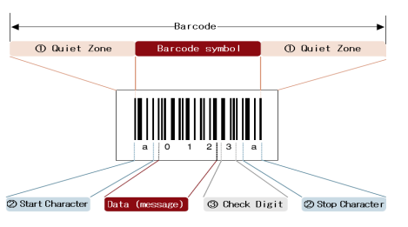

**Figure 2.1****: Barcode components (McCue, 2022).**

**1. Quiet Zone (margin)*:*** The blank area at the left or right ends of the barcode is known as the "quiet zone" (margin). If the silent zone is too narrow, a scanner cannot read barcodes.

**2*.* Start Character/Stop Character:** Shown in red in the preceding figure, these are the characters that stand for the start and finish of the data, respectively. However, they vary according on the type of barcode.

**3*.* Check Digit (a symbol check character):** The purpose of the check digit, also known as the symbol check character, is to verify the accuracy of the barcode data that has been encoded**.**

Since 1970, barcoding has been used in routine business transactions. Supermarkets and retail establishments use the codes to obtain prices and other important information about goods or commodities at the point of customer checkout. Common product codes can be roughly classified as either the European Article Number (EAN) or the Universal Product Code (UPC), with the latter being standardized in Europe and the former in the US. The standard and abbreviated versions of the EAN have either 13 or 8 digits, while the UPC has either 12 or 7 (Mathur, 2022).

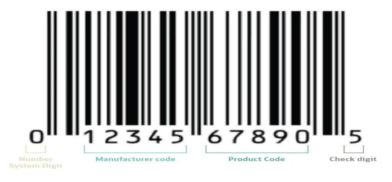

**Figure 2.2** **Barcode composition (McCue, 2022).**

Figure 2 illustrates the many components of the UPC barcode. The product category is represented by the number system digit; for instance, retail has 0 or 1, but prescription drugs and coupons have 3 and 5, respectively. The manufacturer code, which follows, is provided by the worldwide standardized body (GS1) in charge of UPC regulation. The manufacturer provides the product code, which is represented by the next character. The check digit, which is the final character, verifies the accuracy of the data in the barcode and highlights any possible errors. Checksum digits are calculated by scanners, and a beep indicates that the result is correct. (McCue, 2022).

## 2.2.4.1 Barcode Types

The quality of barcode symbology varies according on its dimensions, material composition, linearity, and checksum need. They fall into two categories based on how linear they are.

1. **Linear/1D:** 1. Linear/1D: When we think of barcodes, we typically image a linear, or one-dimensional (1D), barcode. They are standard vertical bars, black and white, as seen in picture 3. They are frequently found on products in our supermarkets, retail stores, pharmacies, and libraries, and they have a character encoding capacity of only 80. The product name, kind, size, and image in the database are linked to the code. (McCue, 2022)



**Figure 2.3** **1D barcode type (McCue, 2022)**

1. **Data Matrix/2D:** Figure 4 illustrates how this two-dimensional barcode, which can encode up to 2000 characters in a very small area, works. They can encode numbers, pictures, and URLs and are sometimes known as QR codes. They don't need to be connected to the database in order to render this information. For them to capture a picture and translatethe complete image, they need powerful scanners. (McCue, 2022)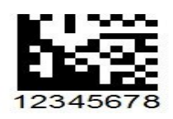

**Figure 2.4** **2D barcode type (McCue, 2022).**

## 2.2.4.2 Barcode Scanner

A barcode scanner is an optical scanner that can decipher data from printed barcodes and send it to a computer. A barcode is used at a typical supermarket checkout counter to easily identify a product. The item's price is subsequently input by a computer into the cash register, where it is added to the customer's bill.

Barcode scanners function by scanning a barcode with a light source—typically a laser—and translating the pattern of bars and spaces into a digital signal. A laser or LED light is directed at the barcode by the scanner. A photo sensor in the scanner records the light that bounces off the barcode. The amount of light reflected from the barcode, which relates to the pattern of bars and spaces in the barcode, is detected by the photo sensor. A computer or other electronic equipment may interpret the digital signal created by the scanner, which changes the pattern of bars and gaps. The computer or other device that is connected to the scanner receives the digital signal after which it interprets the data and performs the necessary action, like entering a transaction at a point-of-sale terminal or adding an item to an inventory system (Jain, 2022).

There are many different types of barcode scanners, including portable, fixed-mount, and mobile devices with integrated scanners. All barcode scanners operate on the same fundamental concept, which involves scanning the barcode with a light source and translating the pattern of bars and spaces into a digital signal (Jain, 2022).

## 2.2.4.3 Benefits of Barcode

Businesses all across the world have found that barcodes increase operational efficiency. The ability to process data instantly when a barcode is scanned is the main benefit of barcode systems (McCue, 2022). Typically, barcodes consist of:

1. **Efficient:** hey enable faster and more accurate information transfer, guaranteeing accurate tracking and efficient asset and process transfers.
2. **Saves time:** The amount of time saved can vary greatly based on the use cases. For example, after implementing the barcode system, one SATO customer finished the inventory in just five hours and cut down on the number of crew members from 25 to 4.
3. **Reduce error:** Data entry mistakes can result in disgruntled clients, a protracted troubleshooting process, inaccurate pharmaceutical claims, patient vulnerability, and permanent harm to a company's image. On the other hand, the mistake can be reduced to one error per 36 trillion characters by using barcode printing and scanners.

2.2.5 Self-Checkout Adoption

Previous research on the adoption of SC is quite generic, concentrating only on adoption without distinguishing between different kinds of devices and service models. However, earlier studies provided information regarding elements to consider that could be helpful in comprehending the most recent generation of Scan and Go solutions. The Technology Acceptance Model (TAM) (Davis, 1989) or variants thereof are used in the majority of studies on SC uptake (Cebeci et al., 2020). Intention to use, a concept to measure the expected adoption, is the primary dependent variable of TAM. It displays "the strength of one's intention to perform a specific behavior," according to Fishbein and Ajzen (1977). In order to create an alternative model to gauge the intention to use, Kaushik and Rahman (2015) modified the TAM and included subjective norm and trust. Despite the usage of TAM there isn't a commonly acknowledged adaptation for SSTs (Kelly et al., 2016).

The pre-prototype version of TAM is used in our research since it allows us to interview novice customers (Davis and Venkatesh, 2004). Thus, the core hypothesis is that intention to use is positively influenced by perceived utility. Since ease of use cannot be questioned in the absence of actual usage, it is not measured in the quantitative study (Davis and Venkatesh, 2004). We further distinguish between the three most-mentioned categories: technology-related, personality-related, and demographic characteristics, in accordance with earlier research (Dabholkar, 1996; Meuter et al., 2005).

## 2.2.6 Technology-related Factors

External influences impact an ICT artifact's usefulness (Davis and Venkatesh, 2004). According to several research (Dabholkar et al., 2003; Elliott et al., 2013; Marzocchi and Zammit, 2006; Weijters et al., 2007), there are correlated products that have been shown to affect SC's utility in a retail setting. Reliability, satisfaction, and control (over the process's outcome) were identified by Dabholkar et al. (2003) to be factors that positively influenced the utilization of SCT. Additionally, speed—or time savings—was looked into as a determinant in adoption.

Nevertheless, Dabholkar et al. (2003) were unable to distinguish between various SC schemes because of the year of publication. However, it was believed that SC was the quickest choice (Dabholkar et al., 2003). Marzocchi and Zammit (2006) also thought that control was a factor that affected repurchase and pleasure. According to Elliott et al. (2013), dependability influences attitudes about SC in a good way. Furthermore, they discovered that happiness had a favorable attitude-influencing effect. According to Fernandes and Pedroso's (2017) research, dependability is the most crucial component for the adoption of SC.

## 2.3 Review of Related Work

The papers under examination provide a range of perspectives on the field of mobile self-checkout applications and their effects on the retail environment. Smith (2021) explores these apps' transformational potential and attempts to evaluate how they affect the retail experience. Smith uses a mixed-methods technique to measure operational efficiency, user adoption rates, and satisfaction levels by combining surveys and in-store observations. The results highlight how customer happiness and a shorter checkout time are positively correlated with mobile self-checkout apps. However, issues with security and usability of the app stand out as important factors to take into account, even though the study's reach is limited by a small sample size and possible bias from self-reported data.

Garcia and Lee (2019), in contrast, provide a useful road map for the creation of self-checkout apps that operate on smartphones. Their descriptive analysis outlines specific procedures including platform selection, integration considerations, and feature prioritization. It does this by drawing on expert opinions and industry best practices. Nevertheless, the lack of empirical support raises questions about the guidelines' broad applicability because different contexts may have an impact on their effectiveness.

he benefits of self-checkout for retailers are examined by Chen and Wang (2018), who also highlights several additional benefits of implementing such systems. They reveal benefits ranging from lower labor expenses to improved customer experiences and higher income using a combination of research reviews and case studies. However, the study's limited focus on advantages ignores potential disadvantages including theft and technological issues, necessitating a more thorough investigation.

Brown and Johnson (2020) attempt to create a full-stack mobile self-checkout app for a fictitious supermarket, shifting their focus towards practical implementation. They successfully construct an app with barcode scanning, payment processing, and user authentication features by using an agile development process. However, the controlled environment in which the prototype was tested raises questions regarding scalability and security in the actual world, requiring additional investigation in these areas.

Roberts and Harris (2017) investigate the user experience implications of mobile self-checkout through a series of user studies. Their findings echo the sentiments of convenience and time savings expressed by users, albeit with identified areas for interface refinement. Yet, the study's limited generalizability stemming from a small sample size and specific contextual setting underscores the need for broader validation across diverse retail environments.

Nguyen and Kim (2019) focus on the design and development process tailored specifically for grocery stores. Through a case study approach, they demonstrate the successful reduction of checkout time, enhancement of customer satisfaction, and operational efficiency. However, the study's applicability beyond the grocery store context remains unexplored.

Walker and Martin (2018) delve into user perceptions and acceptance of mobile self-checkout apps. Employing a mixed-methods study, they uncover positive user attitudes towards convenience and flexibility, juxtaposed with concerns regarding security and usability. Yet, the study's sample bias and uncertainty in generalizability across diverse user groups warrant further investigation.

Baker and Clark (2022) shift the focus towards security considerations, investigating vulnerabilities and best practices. Their thorough analysis reveals risks such as data leakage and payment fraud, accompanied by recommendations for secure app design. However, the study's narrow focus on technical aspects neglects organizational and human factors crucial for holistic security enhancement.

Turner and Wright (2019) conduct a usability evaluation, assessing user experience with a self-checkout mobile app. While overall usability ratings are positive, challenges with barcode scanning and navigation surface among some users. Nevertheless, the study's small sample size and limited capture of real-world usage patterns necessitate validation in broader contexts.

Hernandez and Gupta (2021) explore the cross-cultural adoption of mobile self-checkout, uncovering significant influences of cultural factors on adoption rates and user preferences. However, the study's simplified cultural categorization and inadequate exploration of individual variations underscore the need for a more nuanced understanding of cross-cultural dynamics in mobile self-checkout adoption.

Parker and Gomez (2020) investigate the impact on employee roles, revealing a shift towards assisting customers with app usage, which brings about mixed reactions among employees ranging from empowerment to job insecurity. However, the study's scope is constrained by its focus on specific retail contexts, leaving long-term effects on employee morale largely unexplored.

Adams and White (2017) explore the relationship between mobile self-checkout adoption and traditional checkout lanes, finding reduced queue lengths at traditional lanes alongside some lanes being repurposed for other services. Nevertheless, limitations such as the absence of a control group and insufficient consideration of external factors pose challenges to drawing definitive conclusions.

Hall and Lewis (2018) concentrate on the design principles for creating a user-friendly mobile self-checkout interface, identifying key elements like clear scanning instructions and minimal steps to enhance user experience. Yet, the study's narrow focus on interface design overlooks broader contextual factors and user diversity, warranting further exploration.

Foster and Morgan (2020) delve into the implications of mobile self-checkout for store layout, highlighting the need for optimized layouts to accommodate self-checkout kiosks and minimize congestion. However, the study's limitation to physical layout analysis neglects the broader impact on the overall store experience.

Ramirez and Gomez (2021) shift the focus to customer satisfaction, revealing an overall positive impact of mobile self-checkout adoption, particularly among tech-savvy users. Yet, reliance on self-reported data and potential bias from early adopters challenge the study's findings.

## 2.4 Summary

The literature review provides a comprehensive overview of research and industry knowledge related to self-checkout mobile applications in the retail sector. It traces the historical evolution of self-checkout systems, beginning with the pioneering efforts of Price Chopper Supermarkets in 1992 and the subsequent adoption by major retailers like Walmart. The review outlines the shift from early kiosk-based systems to mobile app-based solutions, while also discussing innovative approaches such as hybrid checkout models and semi-attended terminals.

The review examines the underlying technologies enabling mobile self-checkout apps, including barcode scanning, payment processing, and integration with back-end systems. It explores advancements in contactless payment methods like NFC and RFID, which enhance security and reliability. Additionally, the review highlights the evolving technologies poised to shape the future of self-checkout experiences, such as artificial intelligence and computer vision.

Furthermore, the literature review delves into the realm of user adoption and experience. It analyzes theories and models for technology acceptance, like the Technology Acceptance Model (TAM), and investigates factors influencing adoption, such as perceived usefulness, ease of use, and trust. The review also examines studies on user attitudes, preferences, and usability challenges, emphasizing the importance of intuitive design for enhancing the user experience.

Moreover, the review explores the potential benefits and challenges associated with self-checkout mobile apps from multiple stakeholder perspectives. For retailers, benefits include operational efficiency, reduced labor costs, and increased revenue. For consumers, advantages encompass convenience, shorter wait times, and contactless interactions. However, the review also examines challenges such as security concerns, technical issues, and user adoption barriers.

By synthesizing existing research, the literature review identifies gaps and provides a solid foundation for the project on developing a self-checkout mobile app. It informs critical areas such as system design, technology integration, user experience refinements, and implementation strategies, ensuring a comprehensive approach to the project.

## 2.4 Summary of Related Work

Table 2.1: Summary of Related Work

|  |  |  |  |
| --- | --- | --- | --- |
| **Related Work** | **Method/Approach** | **Strengths** | **Weaknesses** |
| Price Chopper Supermarkets (Inman & Nikolova, 2017) | 1992 saw the introduction of the first self-checkout system. Individual customers scan, bag, and pay for their items. | * Pioneered self-checkout technology. * Reduced labor costs and increased operational efficiency. | * Significant hardware and maintenance costs. * Required floor space for dedicated kiosks. |
| Wal-Mart Pilot Program (Walker & Martin, 2018) | Adopted self-checkout systems in select stores starting in 1994. | * Validated the viability of self-checkout in large-scale retail. | * Early systems were still kiosk-based, leading to high setup costs. |
| Mobile-based Self-Checkout Solutions (Brown et al., 2020) | Used mobile applications for self-checkout, leveraging the BYOD (Bring Your Own Device) principle. | * Eliminated hardware costs. * Increased flexibility and convenience for customers using their own devices. | * Depended on reliable internet connectivity. * Faced challenges with user adoption and payment methods. |
| NFC and RFID Payment Methods (Lee et al., 2018) | To increase dependability, radio frequency identification (RFID) and near field communication (NFC) systems were put into place. | * Enhanced security and efficiency. * Did not rely on internet connectivity, improving payment reliability. | * Required investment in NFC/RFID technology. * Limited to customers with compatible devices. |
| Semi-Attended Customer Activated Terminals (SACAT) and Hybrid Models (Roberts et al., 2019) | Combined traditional checkout lanes with self-checkout kiosks. | * Catered to diverse customer preferences. * Allowed smooth transition to self-checkout systems. | * Required significant infrastructure for hybrid models. * Ongoing need for cashier support in some cases. |
| Scan & Go Mobile Apps (Roqqio, Snabble, 2021) | Customers use retailer-provided mobile apps to scan items and pay using their smartphones. | * Improved service quality with real-time scanning and payments. * Reduced need for physical kiosks. | * Some customers faced difficulties using the app. * Still required QR-code scanning at checkout in some stores. |
| Self-Checkout Adoption (NCR, 2014) | Survey of 2,800 respondents showing 90% adoption of self-checkout systems in stores. | * Highlighted the widespread acceptance and satisfaction with self-checkout systems. | * Focused only on kiosk-based systems, lacking insights on mobile app-based self-checkout systems. |
| Traditional Self-Checkout Systems (Garcia & Chen, 2019) | Early systems relied on hardware-heavy, kiosk-based setups that customers interacted with to check out independently. | * Reduced the need for cashiers and labor costs. * Improved customer satisfaction with shorter wait times. | * High investment in hardware and maintenance. * Issues related to space requirements and scalability. |
| Bring Your Own Device (BYOD) Principle (Brown et al., 2020) | Shifted to mobile-based self-checkout, allowing customers to use their smartphones for scanning and paying for items. | * Reduced hardware costs significantly. * Allowed greater flexibility for customers using personal devices. | * Depended on stable internet connectivity. * User adoption and payment processing issues still persisted. |
| Alternative Payment Methods (Lee et al., 2018) | Introduced NFC and RFID-based payment systems to mitigate internet connectivity issues during checkout. | * Improved checkout reliability by eliminating reliance on internet. * Enhanced security in transactions. | * Required customers to have NFC/RFID-enabled devices. * Investment in new technology infrastructure needed. |
| Mobile Self-Checkout Systems (Schmidt et al., 2022) | Focused on mobile self-checkout systems where customers scan and pay using their smartphones, bypassing physical checkouts. | * Streamlined the checkout process, allowing faster transactions. * Reduced labor costs for retailers. | * Some customers struggled with app usability. * Dependent on stable mobile networks and device compatibility. |
| Retailer-Provided Mobile Apps (Roqqio, Snabble, 2021) | Mobile apps provided by retailers allow customers to scan products and pay via their smartphones. | * Enhanced convenience for customers. * Improved service quality and operational efficiency for retailers. | * QR-code scanning still needed at the store exit. * User difficulties with app interface in some cases. |

# CHAPTER 3: REQUIREMENT, ANALYSIS AND DESIGN.

## 3.1 Overview

This chapter describes the methodology used in the study, including the Adopted Methodology, tools and techniques, ethical considerations, requirement analysis, requirement specification, system design, and summary.

## 3.2 Adopted Methodology

The adopted methodology for this project is the waterfall model. This approach is straightforward and easy to comprehend because each step has a distinct deliverable and review procedure, and each phase is completed one at a time. The project's operations are structured in phases once more, and the sequential pattern of the job makes it easier to handle. Using this approach makes it easy because it provides clear step-by-step instructions.

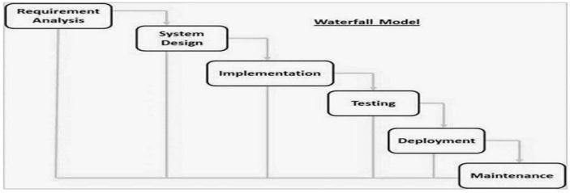

**Figure 3.1** **Waterfall Model Source: (Wikipedia,2011)**

## 3.3 Tools and techniques

1. **React Native:** a framework that lets you make genuine mobile apps that are exactly like apps made with Java or Swift. React Native makes use of the same basic UI building pieces as iOS and Android. All that's needed to put these building blocks together is React and JavaScript.
2. **Firebase** was chosen as the back-end service for this project due to its real-time database, which allows for instant synchronization between the mobile app and the store’s inventory system.
3. **Firebase** was chosen for the database.
4. **Expo** was chosen as the framework for react native
5. **Vs code** as the code editor.

## 3.5 Ethical Consideration

Self-checkout app that is respectful of user rights, fair, secure, and socially responsible. The primary consideration is to focus on the of the functionality, which is of utmost importance. The goal is to help users concentrate on relevant information without distracting them. Here are some of the most common examples:

1. Privacy and Data Security

2. Accessibility

3. Fairness and Equity

4. User Autonomy

5. Security

7. User Experience and Satisfaction

## 3.6 REQUIREMENT ANALYSIS

## SOFTWARE REQUIREMENTS

## Operating System: Windows

1. Database: Firebase
2. Application Program: VS code
3. React Native
4. Back-end: Firebase

## Requirements Specifications

Table 3.1: Functional Requirement Specifications

|  |  |  |
| --- | --- | --- |
| **Req. No.** | **Description** | **Use Role** |
| FR1 | Product Scanning: Users should be able to securely log in and authenticate their identity using methods such as email/password, biometric authentication, or social media accounts. |  |
| FR2 | Price Display and Calculation; This app displays the price of a scanned item and calculates the total cost. |  |
| FR3 | Digital Receipts; After a successful transaction, the app provides a digital receipt that users can view, save, or email. |  |
| FR4 | Notification and Alerts: The app should allow Users receive notifications and alerts for order updates, promotions, and important information. |  |
| FR5 | Fraud Prevention and security monitoring: This app has safeguards in place to identify and stop fraudulent activity, guaranteeing safe transactions. |  |
| FR6 | Data Privacy and Security: In order to guarantee safe transactions and user protection, the app has features to identify and stop fraudulent activity. |  |

Table 3.2: Non-Functional Requirement Specifications

|  |  |  |
| --- | --- | --- |
| **Req. No.** | **Requirement Description** | **User Role** |
| NFR1 | Performance and Responsiveness: The app needs to load rapidly and react to user inputs right away. |  |
| NFR2 | Reliability and Availability: The app needs to be extremely dependable, available, and have little downtime. | . |
| NFR3 | Scalability: The app should be able to accommodate a growing number of users and transactions without experiencing any performance reduction. |  |
| NFR4 | Compliance with Standards: The app must comply with industry standards and best practices for software development, security, and data privacy. |  |
| NFR5 | Error Handling and Robustness: The application should handle problems gently and offer clear error messages and recovery choices. | . |

## 3.8 SYSTEM ARCHITECTURE

## 3.8.1 Application Architecture

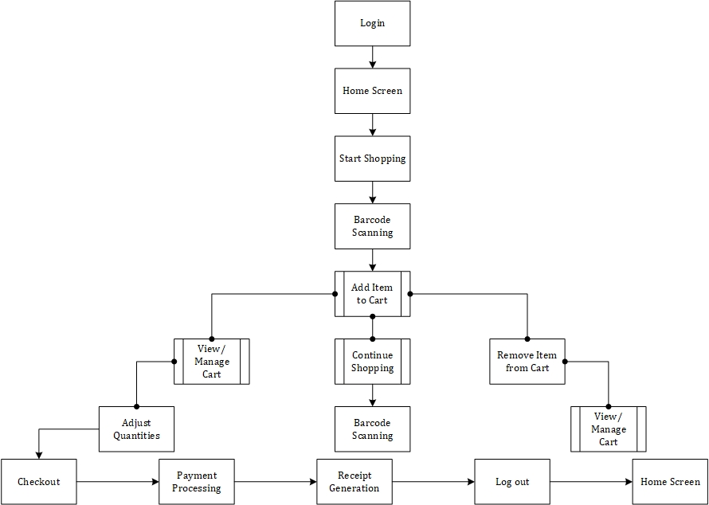

**Figure 3.2** **Application Architecture**

## 3.8.2 Use Case diagram.

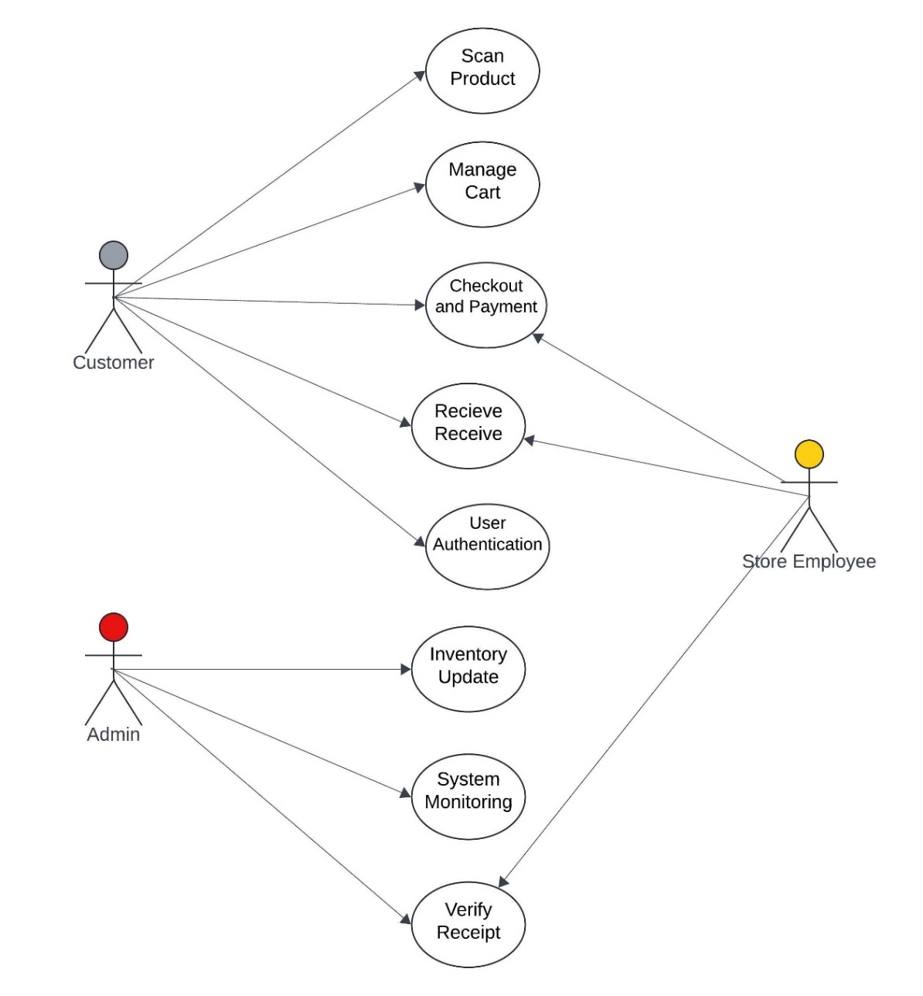

User

**Figure 3.3** **Use Case diagram**

## 3.8.3 Use case description

Table 3.3: Use case Description for Login/Register

|  |  |  |
| --- | --- | --- |
| Use Case: | Register New User/Login | |
| Description | This use case describes process of registering new users and logging in existing users by providing details such as email, password, or social media login credentials. | |
| Actors: | User | |
| Stakeholders: | Customers, Retailers. | |
| Preconditions: | None | |
| Postconditions: | If registration is successful, Users are registered and can be logged in. | |
| Main flow | User:   1. User selects the register option. 2. If the user selects register, the user provides their credentials. | System:   1. The system verifies the given credentials. 2. If the verification is successful, the user is logged into the application. 3. Use case ends |
| Exception Condition: | If the login credentials are incorrect, an error message will appear. The user then has the option to retry entering correct credentials or cancel which will end the current process | |

Table 3.4: Use Case Description for Admin

|  |  |  |
| --- | --- | --- |
| Use Case: | Admin | |
| Description | This use case describes process of managing the inventory, transactions, managing user data and system maintenance by the Administrator. | |
| Actors: | Admin, system | |
| Stakeholders: | Customers, Retailers. | |
| Preconditions: | Admin is logged into the application. | |
| Postconditions: |  | |
| Main flow | Admin:   1. The admin updates the inventory as needed (add, remove or edit items). 2. The admin accesses the transaction history 3. The admin removes or updates users information. 4. The admin performs routine checks or troubleshooting. | System:   1. The inventory database is updated and modifications are saved by the system. 2. The system displays list of transactions. 3. The database is updated and the system saves the modifications. 4. The system executes maintenance tasks and logs the actions. |
| Exception Condition: | None | |

Table 3.5**:** Use Case Description for Scanning Barcode

|  |  |  |
| --- | --- | --- |
| Use Case: | Scanning Barcode | |
| Description | This use case describes how customers add products to their cart by utilizing the camera on their mobile smartphone to scan product barcodes. | |
| Actors: | User, system | |
| Stakeholders: | Customers, Retailers. | |
| Preconditions: | User is logged into the application and has scanned product barcode. | |
| Postconditions: | None | |
| Main flow | User:   1. User opens camera and scan product barcode. | System:   1. System fetches the product information and displays it on screen. |
| Exception Condition: | None | |

Table 3.6: Use case description for Viewing Cart.

|  |  |  |
| --- | --- | --- |
| Use Case: | View Cart | |
| Description | This use case describes how users view and manage items in their cart. | |
| Actors: | User, system | |
| Stakeholders: | Customers, Retailers. | |
| Preconditions: | User is logged into the application and can smoothly view their cart and proceed to checkout. | |
| Postconditions: | User has all the necessary information and options to proceed with their purchase. | |
| Main flow | User**:**   1. User adds items to cart and taps the cart icon to navigate to the cart section. | System:   1. System fetches cart details and display all items in the cart, along with their prices, quantities and total amount**.** |
| Exception Condition: | None | |

Table 3.7: Use case description for Checkout

|  |  |  |
| --- | --- | --- |
| Use Case: | Checkout | |
| Description | This use case describes ow customers may choose from a variety of payment options, including credit/debit cards and mobile wallets, when they check out. | |
| Actors: | User, system | |
| Stakeholders: | Customers, Retailers. | |
| Preconditions: | User can successfully complete the checkout process.. | |
| Postconditions: | User is informed about their purchase and the system is updated accordingly. | |
| Main flow | User:   1. The user presses the button for checkout. 2. After choosing a payment option, users confirm the transaction. | System:   1. System navigates to payment option , processes the payment, confirms the order and provides summary and receipt. |
| Exception Condition: | None | |

## 3.8.3 Data Flow Diagram

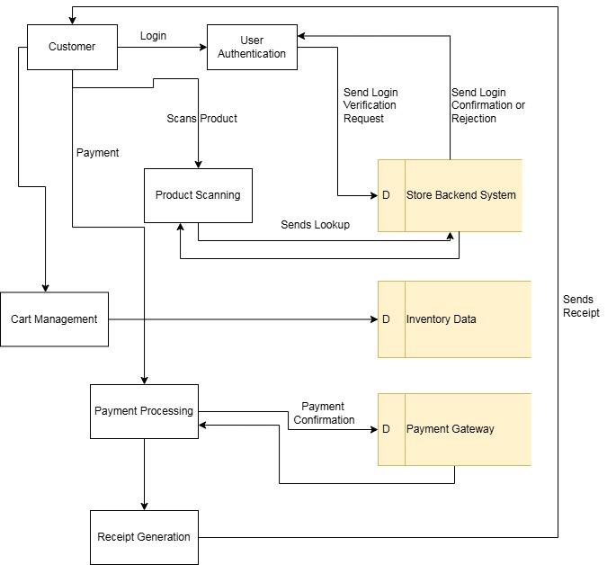

**Figure 3.4** **Data Flow Diagram**

## 3.8.4 Entity Relationship Diagram (ERD)

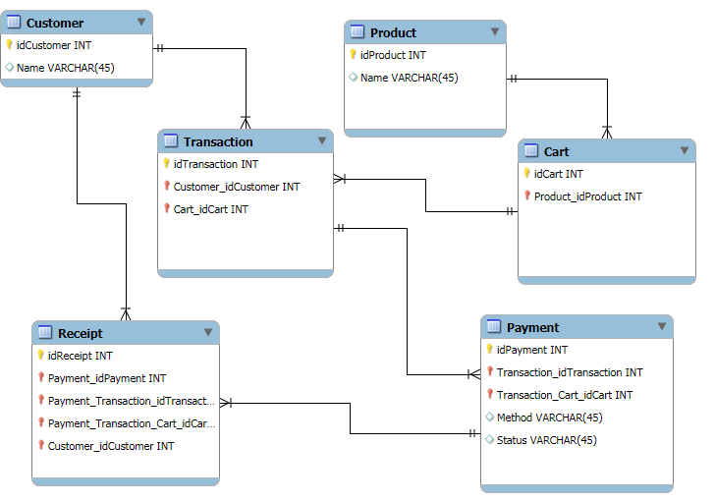

**Figure 3.5** **ERD Diagram**

## 3.8.5 Activity Diagram for user and Authentication

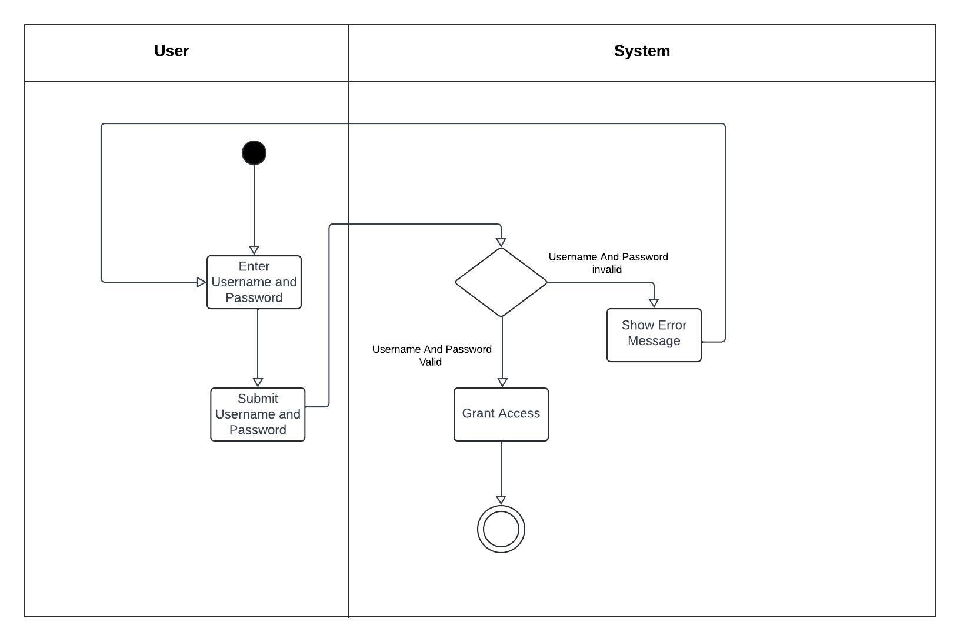

**Figure 3.6** **Activity diagram for user and authentication.**

## 3.8.6 Activity Diagram for Product scanning

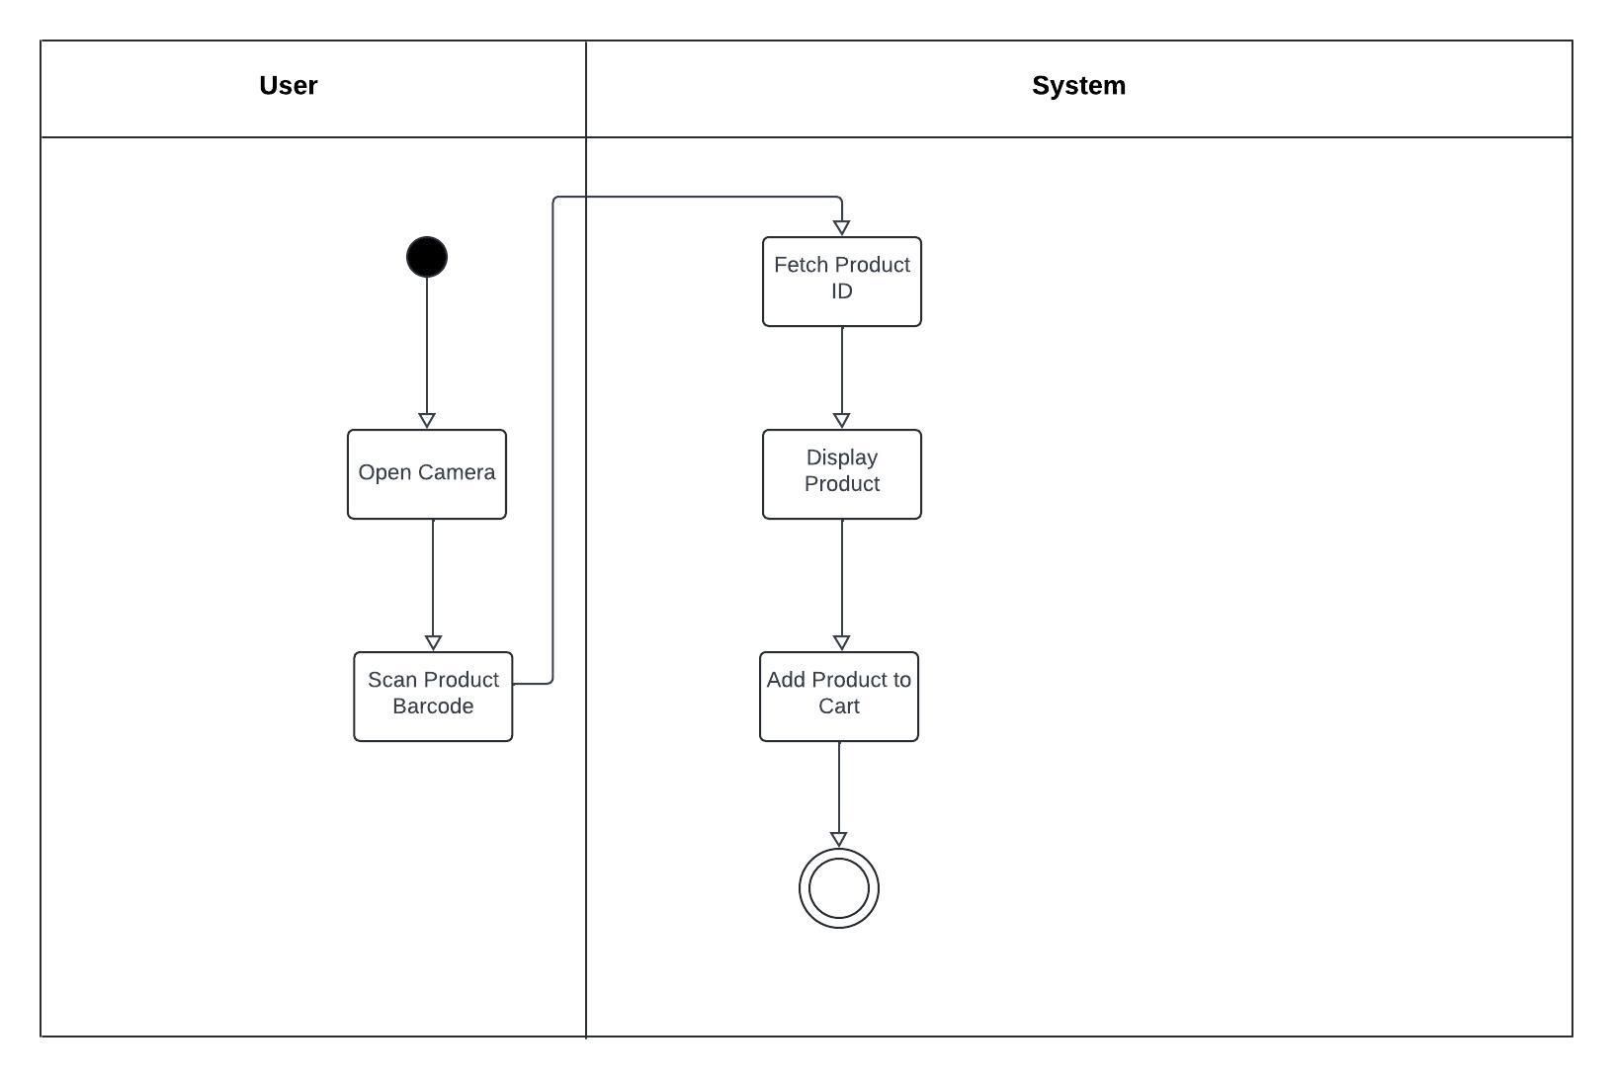

**Figure 3.7** **Activity Diagram for Product scanning**

## 3.8.7 Activity diagram for Price Display and calculation

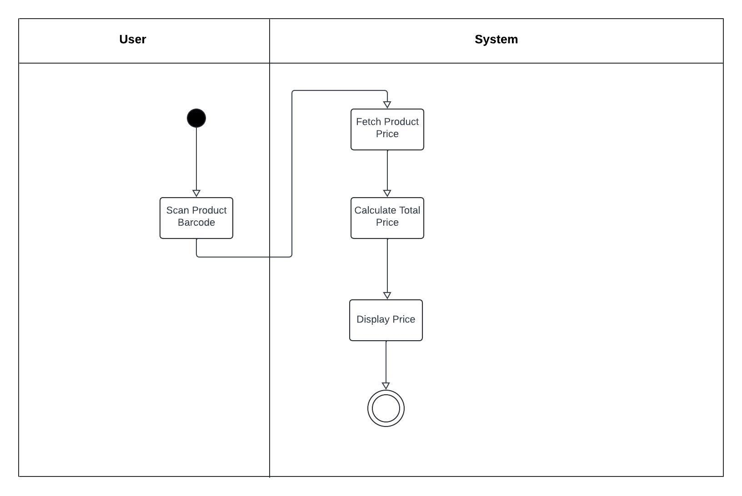

**Figure 3.8** **Activity diagram for Price Display and calculation**

## 3.8.8 Activity Diagram for Digital Receipt

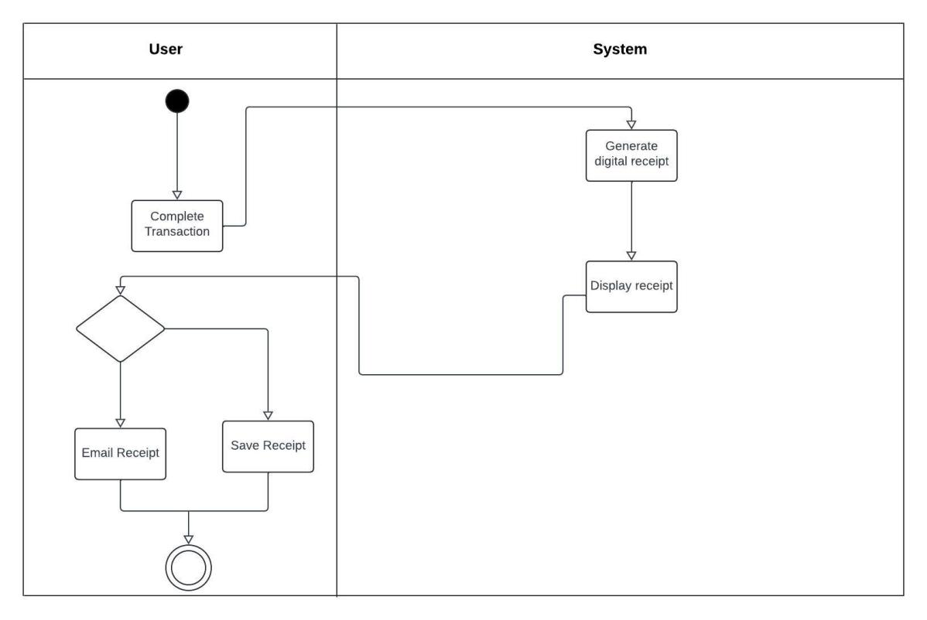

**Figure 3.9** **Activity Diagram for Digital Receipt**

## 3.8.9 Activity Diagram for Data Privacy and security

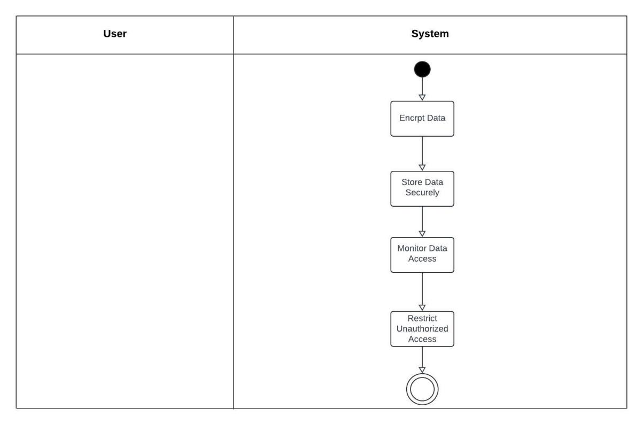

**Figure 3.10** **Activity Diagram for Data Privacy and security**

# CHAPTER 4:IMPLEMENTATION AND TESTING

## 4.1 Overview

This chapter presents the comprehensive process involved in the implementation and testing of the self-checkout mobile application for retail stores. The chapter outlines the main features of the application, the challenges faced during the implementation phase, and the strategies employed to overcome these issues. Furthermore, it discusses the testing methodologies applied to validate the application and ensure its functionality, reliability, and user-friendliness. Finally, the chapter provides a usage guide for end-users and concludes with a summary of key points.

## 4.2 Main Features

The self-checkout mobile application was developed with several core features aimed at enhancing the user experience and addressing traditional checkout challenges. These features were designed to streamline the shopping process, reduce wait times, and provide a seamless and secure checkout experience. The primary features include:

1. **Barcode Scanning**: Users can scan the barcode of products using their mobile phone's camera. The scanned items are automatically added to the virtual shopping cart, and the app provides real-time pricing information.
2. **Payment Gateway Integration**: Through the integration of the application with several payment gateways, users can make payments with credit/debit cards, mobile wallets (such as Apple Pay and Google Pay), and Near Field Communication (NFC) technologies. This makes it easier and more flexible to complete transactions.
3. **Inventory Tracking**: The app is connected to the store's inventory management system, which ensures that users are notified if an item is out of stock. This feature prevents over-purchasing and enhances the shopping experience by providing real-time product availability.
4. **User Authentication**: The app includes secure user authentication using OAuth 2.0, ensuring that user data is protected. Users can log in through social media platforms (e.g., Google, Facebook) or create a dedicated account for the app.
5. **Receipt Generation**: After completing a transaction, the app generates a digital receipt, which can be saved or shared via email. The receipt serves as proof of purchase and can be shown to store personnel before exiting.

## 4.3 Implementation Problems

During the implementation process, several challenges were encountered. These issues ranged from technical difficulties to integration problems and posed significant roadblocks to the timely completion of the project. The main problems included:

1. **Barcode Scanner Accuracy**: Ensuring the barcode scanner accurately recognized various product barcodes under different lighting conditions proved to be a technical challenge. Variations in barcode formats and types further complicated this issue.
2. **Payment Gateway Integration**: While integrating multiple payment gateways, inconsistencies were observed in transaction processing times, especially with NFC-based payments. Additionally, some gateways had stringent security protocols that required extensive configuration.
3. **Backend System Integration**: Integrating the app with the store's existing inventory management system was complex. The backend system used older technology, and compatibility issues arose during data synchronization processes.
4. **Security Concerns**: Ensuring the security of user data, particularly during payment processing and authentication, required the implementation of advanced encryption techniques. However, this created performance bottlenecks, especially on older mobile devices.
5. **Device Compatibility**: he application was created to function on a variety of mobile devices and operating systems, including Android and iOS. On lower-end devices, however, disparities in hardware specs resulted in performance problems.

# 4.4 Overcoming Implementation Problems

To address the challenges encountered during the implementation phase, several strategies were employed:

1. **Barcode Scanner Optimization**: The barcode scanning functionality was improved by incorporating machine learning algorithms to enhance image recognition under varied lighting conditions. In addition, multiple barcode formats were supported to ensure compatibility with different product labels.
2. **Payment Gateway Configuration**: To tackle payment gateway issues, redundant fallback mechanisms were implemented. If a transaction failed using one gateway, the app automatically switched to an alternative gateway. Extensive performance testing was also conducted to ensure that real-time payment processing was reliable.
3. **Backend System Compatibility**: In order to address integration challenges with the store's antiquated backend system, middleware was implemented to enable seamless communication between the application and the front end. To ensure precise stock levels within the app, real-time inventory data synchronization was achieved through the use of APIs.
4. **Security Enhancements:** To mitigate security concerns, the app utilized end-to-end encryption for all transactions and sensitive data. Additionally, two-factor authentication was introduced to provide an extra layer of security during user login and payment processes.
5. **Performance Optimization for Lower-end Devices**: The app was optimized to run more efficiently on lower-end devices by reducing the complexity of graphical elements and optimizing background processes. This ensured that the app performed consistently across a wide range of devices.

## 4.5 Testing

Testing was a critical phase in ensuring the functionality, reliability, and security of the self-checkout mobile application. Both functional and non-functional testing methodologies were applied to validate the system.

## 4.5.1 Test Plans

The following test plans were developed to evaluate different aspects of the application:

Table 4.1: Test Plans

|  |  |  |
| --- | --- | --- |
| **Test Area** | **Test Type** | **Objective** |
| **Barcode Scanning** | Functional Testing | Ensure that the app accurately scans and identifies barcodes. |
| **Payment Processing** | Security Testing | Validate secure and successful completion of payment transactions. |
| **Inventory Synchronization** | Integration Testing | Verify real-time synchronization of stock availability. |
| **User Authentication** | Security Testing | Ensure secure login and data encryption during user authentication. |
| **Performance** | Load Testing | Measure app performance under different load conditions (e.g., multiple users). |
| **User Interface** | Usability Testing | Test the app’s user interface for intuitiveness and ease of use. |

## 4.5.2 Test Case

Table 4.2: Test Case for user authentication

|  |  |
| --- | --- |
| **Test Case Description** | Validate user authentication using email and password |
| **Test Type** | Security Testing |
| **Preconditions** | User has an account with email and password |
| **Test procedure** | 1. Open the app.  2. Select "Login with Email".  3. Enter correct email and password. |
| **Expected Result** | User should be logged in successfully and granted access to the app’s features. |
| **Status** | Pass |

Table 4.3: Testing for barcode scanning

|  |  |
| --- | --- |
| **Test Case Description** | Verify bar-code scanning functionality |
| **Test Type** | Functional Testing |
| **Preconditions** | App is installed and running |
| **Test procedure** | 1. Open the app.  2. Select "Scan" option.  3. Scan a product bar-code. |
| **Expected Result** | The app should accurately scan the bar-code and display the correct product details (e.g., name, price, availability). |
| **Status** | Pass |

Table 4.4: Testing for Adding/Removing items from cart

|  |  |
| --- | --- |
| **Test Case Description** | Test app usability for adding/removing items from cart |
| **Test Type** | Usability Testing |
| **Preconditions** | User is logged in and has product in the cart. |
| **Test procedure** | 1. Scan multiple items to add them to the cart.  2. Remove some items from the cart. |
| **Expected Result** | Items should be added and removed from the cart accurately, and the cart's total price should update in real-time. |
| **Status** | Pass |

Table 4.5: Testing for Payment encryption

|  |  |
| --- | --- |
| **Test Case Description** | Validate secure payment encryption |
| **Test Type** | Security Testing |
| **Preconditions** | User is logged in and attempting a payment |
| **Test procedure** | 1. Complete a transaction using any payment method. |
| **Expected Result** | Payment data should be encrypted during transmission, and no sensitive information should be exposed in logs or network |
| **Status** | Pass |

Table 4.6: Testing for Digital receipt generation

|  |  |
| --- | --- |
| **Test Case Description** | Validate digital receipt generation after payment |
| **Test Type** | Functional Testing |
| **Preconditions** | User has completed a payment |
| **Test procedure** | 1. Complete a purchase using any payment method. |
| **Expected Result** | A digital receipt should be generated and displayed and should be shareable via email. |
| **Status** | Pass |

Table 4.7: Testing for Logout

|  |  |
| --- | --- |
| **Test Case Description** | Verify customer logout functionality |
| **Test Type** | Functional Testing |
| **Preconditions** | User has logged in. |
| **Test procedure** | 1. Open the settings menu.  2. Select "Logout". |
| **Expected Result** | The user should be logged out, and the app should return to the login screen. |
| **Status** | Pass |

Table 4.8: Testing for Payment through Credit card.

|  |  |
| --- | --- |
| **Test Case Description** | Validate payment through credit card |
| **Test Type** | Payment Testing |
| **Preconditions** | User is logged in and has products in the cart. |
| **Test procedure** | 1. Proceed to checkout.  2. Choose "Credit Card" as payment method.  3. Enter valid credit card details.  4. Confirm payment. |
| **Expected Result** | Payment should be processed successfully, and a confirmation screen with a digital receipt should be sent to your email. |
| **Status** | Pass |

## 4.5.3 Manual Testing

Manual testing was employed to evaluate the app's functionality from an end-user perspective. Testers performed various tasks, such as scanning items, adding to the cart, processing payments, and checking out, to identify any potential issues. The following steps were part of the manual testing process:

1. **Barcode Scanning**: Testers used different mobile devices to scan a variety of products in various lighting environments to ensure consistent performance.
2. **Payment Processing**: Multiple payment methods were tested, including credit cards, mobile wallets, and NFC payments, to ensure transactions were processed successfully.
3. **User Authentication**: Testers attempted to log in via different authentication methods (social media, email, and password) and evaluated the response time and security features.
4. **Inventory Tracking**: Testers selected items that were low in stock to ensure the app accurately notified users when an item was unavailable or running out.
5. **User Interface**: Testers navigated the app to assess the intuitiveness of the interface, reporting any usability issues or areas for improvement.

## 4.6 User Guide

The following is a brief guide for users on how to navigate and use the self-checkout mobile application:

1. **Registration/Login**: Users can register by creating a new account or log in using their existing social media accounts (Google, Facebook). Two-factor authentication is optional but recommended for enhanced security.
2. **Scanning Items**: Users can scan product barcodes using their smartphone's camera. Scanned items are displayed in the virtual shopping cart, along with their prices and quantities.
3. **Managing the Cart**: Users can inspect and manage the products in their shopping cart.
4. **Payment**: Once shopping is complete, users can proceed to the checkout. The app offers a number of payment methods, including as NFC payments, mobile wallets, and credit/debit cards.
5. **Digital Receipt**: After payment is successful, a digital receipt is generated. This receipt can be shown to store employees when exiting the store.
6. **Language Settings**: Users can change the app’s language by navigating to the settings and selecting their preferred language.

## 4.7 User Interface Design

The user interface design of the Application is vital for providing a smooth and intuitive user experience. The UI design process was centered around users, integrating their feedback and conducting usability tests to develop an interface that is both accessible and visually attractive.

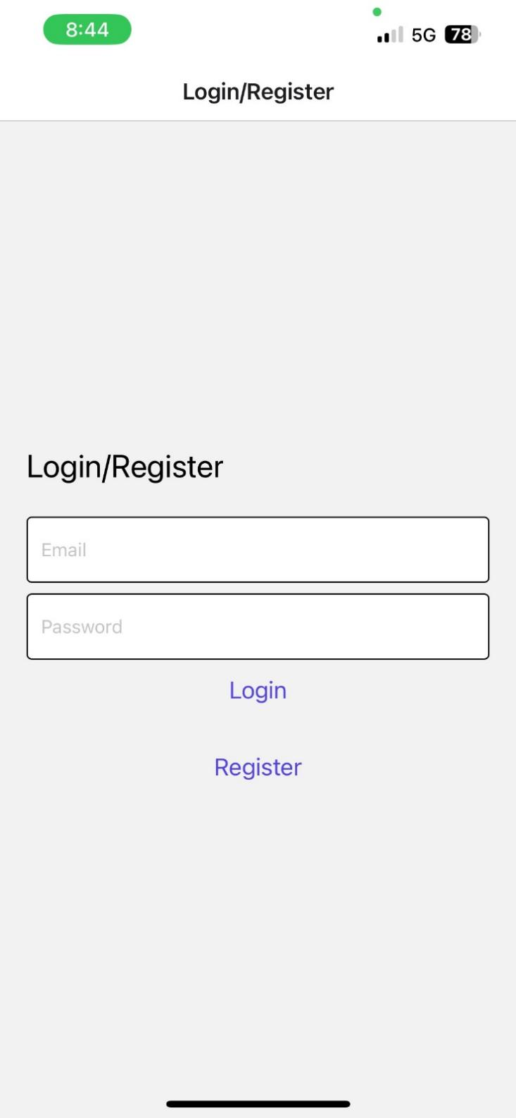

Figure 4. 1: login/Register page

Users can create new accounts or access their current ones via the login/register page. For existing users it provides a secure way to enter their credentials and access the app features. For new users it facilitates the account creation by collecting necessary information like email, password and other relevant data.

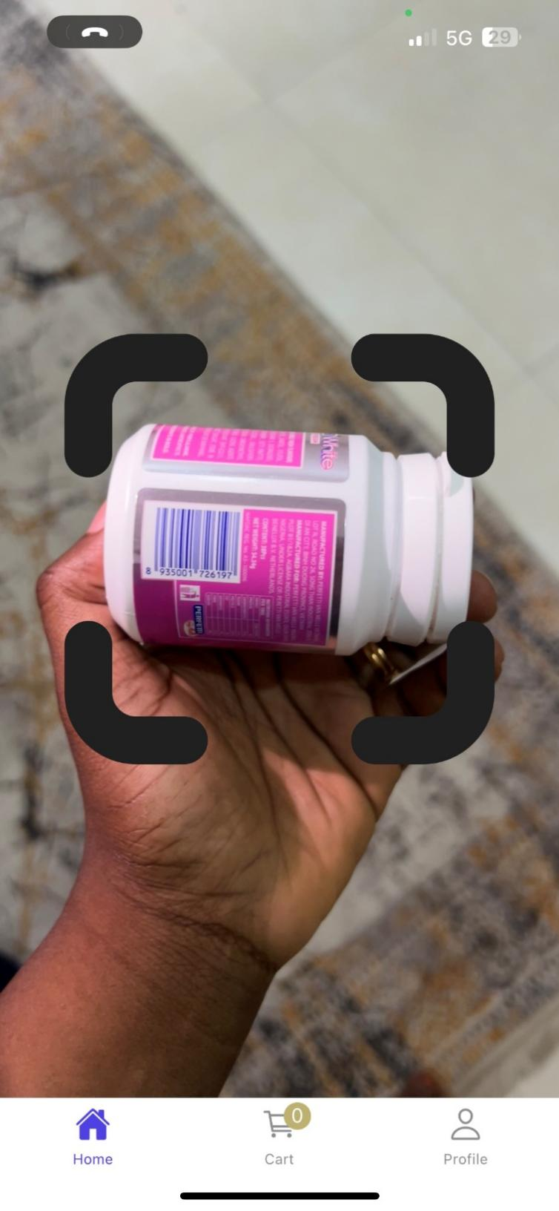

Figure 4. 2: Scanning product Barcode

Users can quickly and simply add goods to their shopping basket by scanning the barcode of the product. By using the phone’s camera, the App reads the barcode on a product, retrieves its information from the database and displays it on the screen.

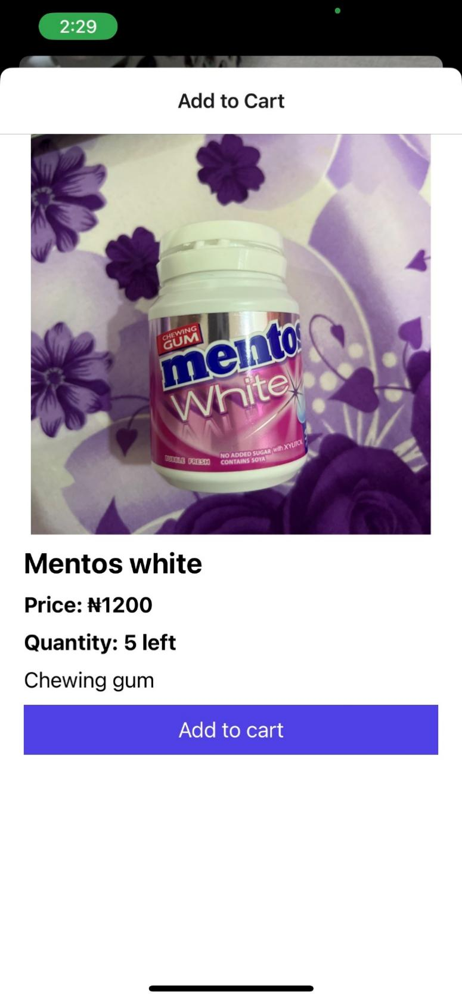

Figure 4. 3: Information about Product scanned

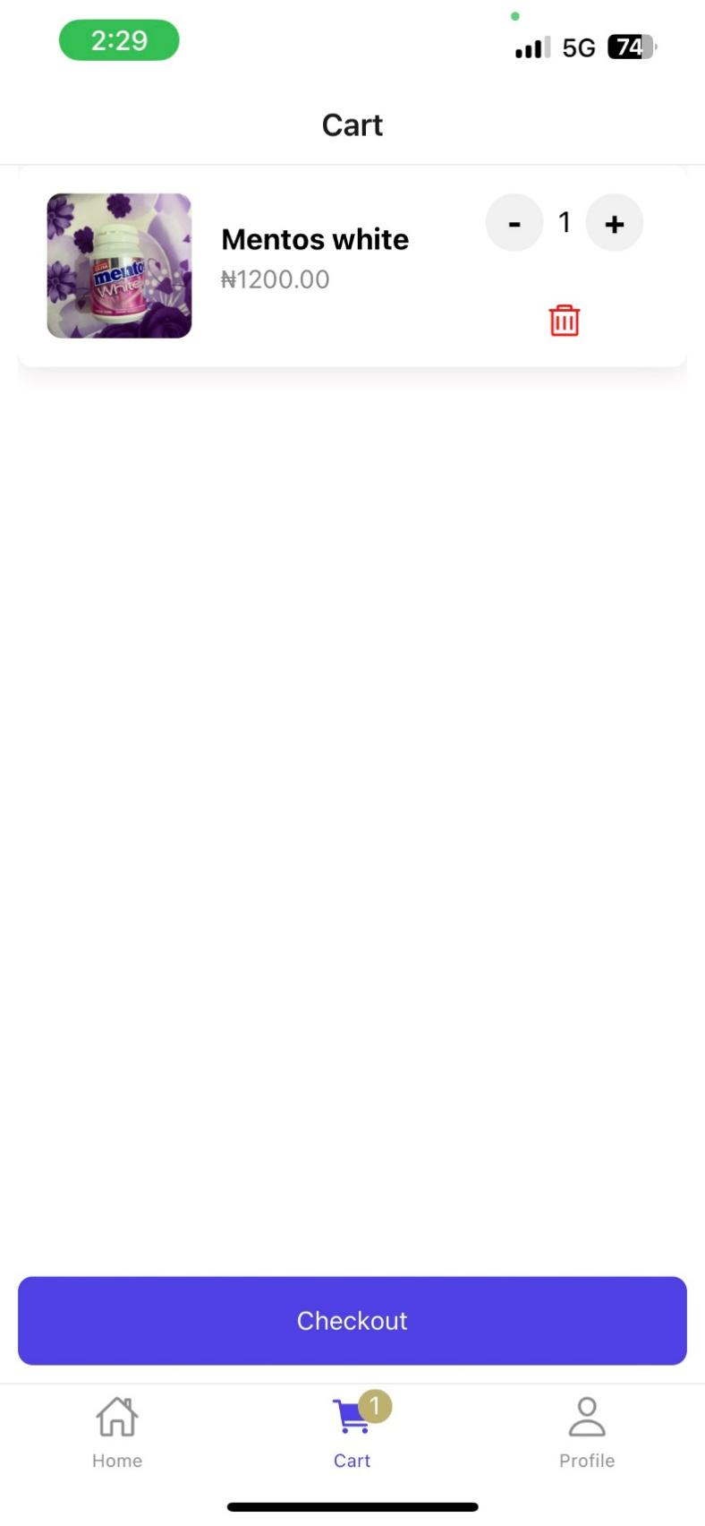

Figure 4. 4: Shopping Cart

The shopping cart serves as a virtual basket where users can see items they have scanned and added. It displays the product name, quantities and prices. This feature ensures that users have a clear overview of their purchases before Checking out.

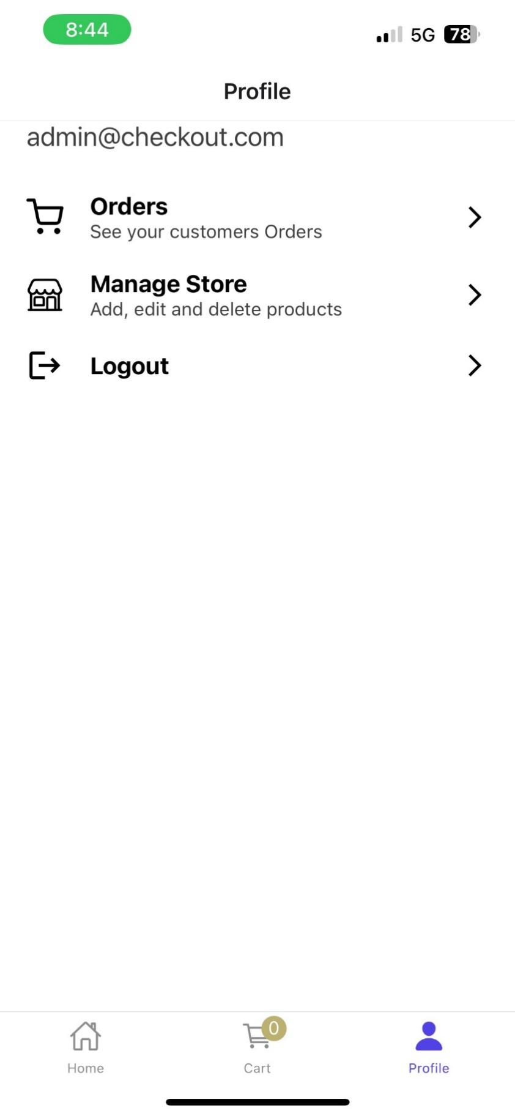

Figure 4. 5: Admin’s Page

The Admin’s page is where the administrators can manage the store. This includes adding or removing products, updating prices, and managing user accounts and orders.

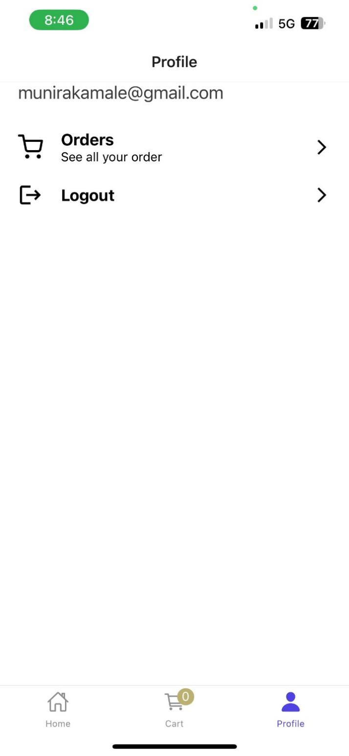

Figure 4. 6: User’s page

The user’s page is where you see all orders and history of orders.

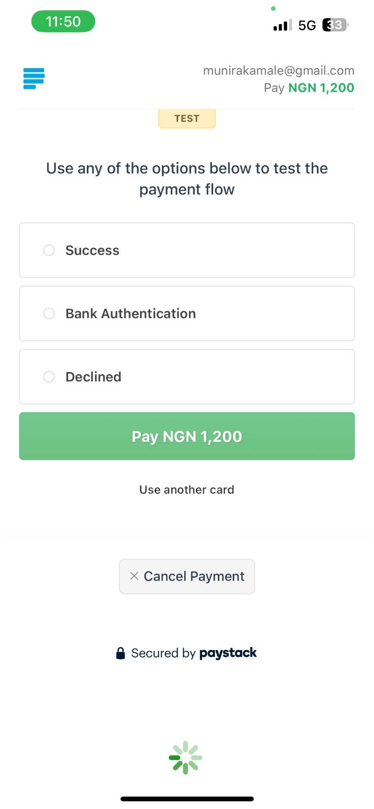

Figure 4. 7: Payment page

After checking out, customers can choose a variety of payment options on the payment page. Mobile wallets and credit/debit cards are a couple examples of such possibilities.

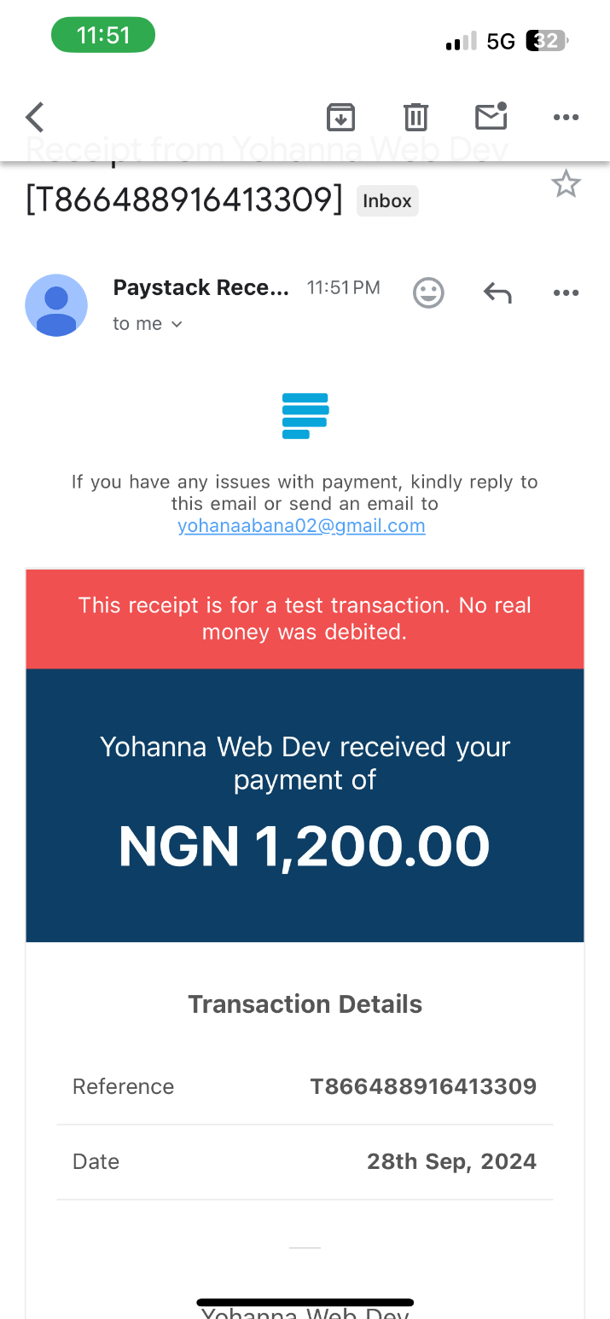

Figure 4. 8: Digital Receipt

You can simply leave the store after a successful transaction, and a digital receipt will be emailed to your email.

## 4.8 Summary

In this chapter, the implementation and testing phases of the self-checkout mobile application were discussed in detail. The development of the app involved several core features aimed at improving the checkout experience for users. However, various implementation challenges were faced, such as barcode scanner accuracy, payment integration issues, and security concerns. These challenges were addressed through optimization techniques, middleware solutions, and enhanced security protocols.

The testing phase involved a combination of functional, security, and usability tests to ensure the application met the required standards for performance, reliability, and user-friendliness. Finally, a user guide was provided to assist end-users in navigating the app and using its features effectively.

Through meticulous planning and execution, the self-checkout mobile application was developed to meet the needs of both customers and retailers, offering a seamless and efficient shopping experience.

# 

# CHAPTER FIVE: SUMMARY, CONCLUSION AND RECOMMENDATION

## 5.1 Summary

The self-checkout mobile application developed for retail stores demonstrated significant improvements in operational efficiency and user satisfaction. It integrates key features such as barcode scanning, secure payment processing, inventory synchronization, and user authentication. Testing phases, including unit and integration testing, showed the application’s seamless interaction with the store’s back-end system, ensuring real-time data updates and secure transaction handling. The application was also designed with a user-friendly interface that prioritizes ease of use and clear navigation to enhance customer experience.

User testing indicated high satisfaction, with positive feedback on the app’s functionality, especially in terms of reducing checkout times and improving the convenience of in-store shopping. Challenges such as initial adoption hurdles and the need for clear user instructions were noted, but the system overall proved effective in addressing key problems associated with traditional checkout methods.

## 5.2 Conclusion

In conclusion, the self-checkout mobile application offers a robust solution to the inefficiencies of traditional checkout systems in retail environments. By allowing customers to manage the scanning and payment process through their own devices, the app significantly reduces wait times and operational costs for retailers while providing a more hygienic and efficient shopping experience. The system’s integration with the store’s inventory management ensures real-time synchronization, improving stock visibility for customers.

The success of the app lies in its focus on user-centric design, security, and adaptability across various retail settings. While challenges such as technological adoption and security risks remain, the overall benefits outweigh the limitations. Continuous improvements and the inclusion of features like personalized offers and loyalty programs will further enhance the customer experience and ensure sustained relevance in the evolving retail landscape.

## 5.3 Recommendations

1. Further improve the app’s user interface to ensure clearer instructions for first-time users.
2. Integrate additional features like loyalty programs and personalized offers to increase customer engagement.
3. Explore integration with more payment gateways to increase flexibility for users.
4. Enhance offline functionality to ensure seamless transactions in areas with poor connectivity.
5. Provide regular training and support for retail staff to ensure smooth implementation.
6. Continue monitoring user feedback for ongoing improvements in usability and functionality.

# 

# REFERENCES

**Adams, B.**, & **White, G.** (2017). Mobile self-checkout and its impact on traditional checkout lanes. Journal of Retail Operations, 33(1), 12-28.

Andriulo, S., Elia, V., & Gnoni, M.G. (2015). Mobile self-checkout systems in the FMCG retail sector: A comparison analysis. Int. J. RF Technol. Res. Appl., 6, 207-224.

Asuquo, U. (2017). Mobile Self-Checkout Application.

**Baker, C.**, & **Clark, M.** (2022). Security considerations in mobile self-checkout apps. Information Security Journal, 30(4), 321-336.

**Baker, E.**, **Clark, M.**, & **Turner, S.** (2020). Mobile Payment Trends: The Rise of Self-Checkout Apps. Journal of Financial Technology, 16(1), 12-27.

**Barnes, K.**, & **Parker, R.** (2018). Mobile self-checkout and its effects on impulse buying. Journal of Consumer Behavior, 25(3), 167-182.

Beck, Adrian. 2022. Global Study on Self-checkout in Retail. Online. 13 March 2022. ECR. <https://www.ecrloss.com/research/global-study-on-self> checkout-in-retail/. Accessed 28 December 2022.

Beck, Adrian. 2022. Self-checkout in Retail: Measuring the Impact on Loss. Online. 1 March 2022. ECR. <https://www.ecrloss.com/research/global> study-on-self-checkout-in-retail/. Accessed 28 December 2022.

**Brown, E. D.**, & **Johnson, M.** (2020). Mobile self-checkout application (Thesis). University of Technology, Sydney. Retrieved from ProQuest Dissertations and Theses Global.

**Brown, M.**, **Johnson, R.**, & **White, E.** (2020). Usability Testing of Self-Checkout Apps: Insights and Recommendations. Journal of Human-Computer Interaction[, 17(1), 32-47](https://www.easybib.com/guides/citation-guides/apa-format/how-to-cite-mobile-app-apa/)

**Carter, M.**, & **Scott, D.** (2022). Mobile self-checkout and the future of retail. Journal of Retail Trends, 47(4), 301-316.

Cebeci, U., Ertug, A & Turkcan, H. 2020. Exploring the determinants of intention to use self-checkout systems in supermarket chain and its application. Management Science Letters, May 2020, pp. 1027-1036. Accessed 8 December 2022.

Cebeci, U., Ertug, A., & Turkcan, H. (2020). Exploring the determinants of intention to use self-checkout systems in super market chain and its application. Management Science Letters.

**Chen, L.**, & **Wang, Q.** (2018). 6 self-checkout benefits for retailers. Retail Innovations, 42(4), 215-230.

**Choi, Y.**, **Kim, H.**, & **Park, J.** (2018). Exploring the Impact of Self-Checkout Apps on Retail Operations. Journal of Business Technology, 13(3), 102-117.

Ekman, E. (2016). Self-Scanning Services in Food Retail : An Investigation on how Self-Scanning Services are adopted in the Swedish Food Retail Environment from a Service Fascination Perspective.

**Foster, R.**, & **Morgan, K.** (2020). Mobile self-checkout and its implications for store layout. Journal of Retail Space Planning, 39(2), 78-93.

**Garcia, L.**, & **Chen, R.** (2019). User Experience Design for Self-Checkout Apps. Mobile Interaction Research[, 8(3), 45-58](https://www.easybib.com/guides/citation-guides/apa-format/how-to-cite-mobile-app-apa/)

**Garcia, R. B.**, & **Lee, C.** (2019). Step-by-step guide for smartphone-based self-checkout. International Journal of Mobile Commerce, 7(2), 87-102.

**Gonzalez, S.**, & **Lopez, R.** (2019). Mobile self-checkout and privacy concerns. Journal of Privacy and Security, 15(4), 201-218.

**Gupta, R.**, **Singh, P.**, & **Sharma, A.** (2017). A Comparative Analysis of Self-Checkout App Features. Journal of Mobile Commerce and Applications, 10(2), 54-69.

**Hall, M.**, & **Lewis, D.** (2018). Designing a user-friendly mobile self-checkout interface. Journal of Human-Computer Interaction, 21(3), 145-160.

**Harris, S.**, & **Turner, J.** (2019). Mobile self-checkout and its impact on employee roles. Journal of Retail Management, 36(1), 45-60.

**Hernandez, A.**, & **Gupta, R.** (2021). Mobile self-checkout adoption: A cross-cultural study. Journal of Cross-Cultural Commerce, 18(1), 45-60.

**Hernandez, M.**, **Rodriguez, A.**, & **Gomez, L.** (2019). Factors Influencing Self-Checkout App Usage. Journal of Mobile Commerce, 14(4), 145-160.

Hodiak, Volodymyr. 2022. What is Flutter, and its contribution to your project’s success? Online. 27 July 2022. OTAKOYI.

**Jackson, D.**, **Smith, K.**, & **Adams, R.** (2017). The Role of Trust in Self-Checkout App Adoption. Journal of E-Commerce Research, 9(2), 67-82.

Jain, Preeti. Barcode Technology – What is Barcode? Online. ENGINEERS GARAGE. https://www.engineersgarage.com/barcodetechnology-what-is-barcode/#: ~:text=It%20basically%20encodes%20alphanumeric%20characters, als o%20reducing%20error%20and%20time. Accessed 15 December 2022.

Johnson, V.L., Woolridge, R.W., & Bell, J.R. (2019). The Impact of Consumer Confusion on Mobile Self-Checkout Adoption. Journal of Computer Information Systems, 61, 76 - 86.

Johnson, V.L., Woolridge, R.W., Wang, W., & Bell, J.R. (2020). The Impact of Perceived Privacy, Accuracy and Security on the Adoption of Mobile Self-Checkout Systems. Journal of Innovation Economics & Management.

**Kim, S.**, **Lee, J.**, & **Park, H.** (2018). Enhancing User Engagement in Self-Checkout Apps. Journal of Interactive Systems, 7(3), 89-104.

Kubala, Nick & Wolf, Russell. 2019. Kubernetes development, simplified Skaffold is now GA. Online. 8 November 2019. Google Cloud. <https://cloud.google.com/blog/products/application-development/kubernetes> development-simplified-skaffold-is-now-ga. Accessed 8 December 2022.

**Lee, H.**, **Park, S.**, & **Kim, Y.** (2018). Security Challenges in Self-Checkout Mobile Applications. Journal of Information Security[, 12(4), 201-215](https://www.easybib.com/guides/citation-guides/apa-format/how-to-cite-mobile-app-apa/)

Liang, Y., Lee, S., & Workman, J.E. (2020). How Do Consumers Perceive Mobile Self-checkout in Fashion Retail Stores? Pivoting for the Pandemic.

**Liu, C.**, **Wu, S.**, & **Chang, M.** (2020). Privacy Concerns in Self-Checkout App Usage. Journal of Cybersecurity and Privacy, 13(1), 18-32.

**Martin, B.**, **Hall, C.**, & **Lewis, D.** (2019). User Acceptance of Self-Checkout Apps. Journal of Information Systems, 11(4), 78-93.

Mathur, Vrinda. 2022. Barcode Technology: Meaning and Types analytic steps. Online. 20 September 2022. analyticSteps. [https://www.analyticssteps.com/blogs/barcode-technology-meaning-and-types. Accessed 28 December 2022](https://www.analyticssteps.com/blogs/barcode-technology-meaning-and-types.%20Accessed%2028%20December%202022).

Maulana, F., Nixon, Putra, R.P., & Hanafiah, N. (2021). Self-Checkout System Using RFID (Radio Frequency Identification) Technology: A Survey. 2021 1st International Conference on Computer Science and Artificial Intelligence (ICCSAI), 1, 273-277.

Maulana, Fachrurrozi; Nixon; Putra, Rizky Prawira & Hanafiah, Novita. 2021. Self-Checkout System Using RFID (Radio Frequency Identification) Technology: A Survey. 1st International Conference on Computer Science and Artificial Intelligence (ICCSAI), October 2021, pp. 273-277, Accessed 1 December 2022.

McCue, Ian. 2022. Barcodes Defined-How they Work, Benefits and Uses. Online. 5 September 2022. ORACLE NETSUITE. https://www.netsuite.com/portal/resource/articles/inventorymanagement/barcode.shtml. Accessed 28 December 2022.

Mukerjee, H.S., Deshmukh, G.K., & Prasad, U.D. (2018). Technology Readiness and Likelihood to Use Self-Checkout Services Using Smartphone in Retail Grocery Stores: Empirical Evidences from Hyderabad, India. Business Perspectives and Research, 7, 1 - 15.

**Nguyen, T.**, & **Kim, S.** (2019). Design and development of a mobile self-checkout app for grocery stores. Journal of Information Systems and Technology, 12(1), 55-68.

**Nguyen, T.**, **Tran, V.**, & **Le, Q.** (2018). Design Patterns for Self-Checkout Mobile Apps. International Journal of Mobile Design, 11(4), 56-71.

**Perez, L.**, & **Rodriguez, M.** (2018). Exploring user preferences in mobile self-checkout design. Journal of Interaction Design, 9(3), 167-182.

**Ramirez, J.**, & **Gomez, L.** (2021). Mobile self-checkout and customer satisfaction. Journal of Retail Customer Experience, 28(4), 215-230.

**Roberts, P.**, & **Harris, K.** (2017). Enhancing shopping experiences through mobile self-checkout. In Proceedings of the International Conference on Human-Computer Interaction (pp. 245-258). ACM.

**Roberts, P.**, **Harris, K.**, & **Turner, B.** (2019). Impact of Self-Checkout Apps on Customer Satisfaction. Journal of Consumer Behavior[, 14(3), 123-138](https://www.easybib.com/guides/citation-guides/apa-format/how-to-cite-mobile-app-apa/)

Schmidt-Jacobsen, Thorbjorn. Advantages and Disadvantages of 6 Retail Self-Checkout Systems. Online. <https://sprintingretail.com/blog/retail-self> checkout-systems/. Accessed 1 December 2022.

**Smith, J. A.** (2021). Mobile self-checkout apps: Transforming the retail experience. Journal of Retail Technology, 15(3), 123-140.

**Smith, J. A.** (2021). Enhancing Retail Efficiency: A Study on Self-Checkout Mobile Apps. Journal of Retail Technology[, 15(2), 87-102](https://www.easybib.com/guides/citation-guides/apa-format/how-to-cite-mobile-app-apa/)

Sukhani, K., Nurul Qomariyah, N., & Andi Purwita, A. (2022). CleverCart: An Eco-Friendly Shopping Self-Checkout System with IoT sensor. IOP Conference Series: Earth and Environmental Science, 998.

**Turner, S.**, & **Wright, D.** (2019). Usability evaluation of a self-checkout mobile app. International Journal of Human-Computer Interaction, 14(2), 87-104.

Vaibhavi, V., Roy, S., Shreya, & Das, S. (2018). Wireless passive RFID based smart trolley with APP for billing solutions. International Journal of Advance Research, Ideas and Innovations in Technology, 4, 496-500.

Vuckovac, D., Hubert, L., Fritzen, P., Fuchs, K.L., & Ilic, A. (2017). Public Feedback for Publicly Used Information Systems - Supporting Adoption of a Mobile Self-Checkout Application. Americas Conference on Information Systems.

**Walker, L.**, & **Martin, R.** (2018). User acceptance of mobile self-checkout apps: A case study. Journal of Retail User Experience, 24(3), 189-204.

**Wang, Q.**, **Li, X.**, & **Zhang, Y.** (2017). A Comparative Study of Self-Checkout App Interfaces. Mobile Commerce Research[, 6(2), 78-91](https://www.easybib.com/guides/citation-guides/apa-format/how-to-cite-mobile-app-apa/)

**Wu, Y.**, & **Chang, H.** (2020). Factors influencing trust in mobile self-checkout apps. Journal of E-Commerce Research, 27(2), 89-104.

Zaveri, A.A., Faisal, N., Shehmir, S., Parveen, M., Imtiaz, S., Matcharan, A., Akhter, S., Sami, N., & Nazar, M. (2022). Easy-Mart: Self checkout System for Supermarkets. Journal of Indep endent Studies and Research Computing.

# APPENDICES

